KIRKWHELPINGTON PARISH COUNCIL
AGENDA
Agenda for the Annual meeting of Kirkwhelpington Parish Council to be held at the Memorial Hall, Kirkwhelpington on Tuesday 7th May 2019 commencing after the Annual Meeting of the Parish at 7pm
2019/27 Apologies for Absence
2019/28 Declarations of Interest
2019/29 Public questions
2019/30 Minutes of previous meeting held Tuesday 5th March 2019
2019/31 Matters arising from previous meeting held Tuesday 5th March 2019
- Meadowlands Wall
- Trees
- St Oswald’s Way signpost
- Village web-site
- Seat repair
- Purchase of goalposts
- Play area repairs
2019/32 Correspondence: Grant acknowledgement from Northumberland Theatre Company; CPRE newsletter
2019/33 Finance
2019/33/01 Bank Balance: £26211.92 as at 30/04/19
2019/33/02 The following accounts require authorisation:
- Kirkwhelpington Memorial Hall – W/C maintenance - £255.50;
- C Miller – March, April salary and expenses – £ 273.18
- HMRC - PAYE on above - £57.20
- B& S Chains – swing seat/shackle - £155.47
- W Graham & Co – drainage - £9739.80
- Robson & Cowan – service grasscutter £389.53; service lawnmower £129.55; fuel £52.39
- Came and Company – annual insurance premium - £590.48
- NALC – annual subscription - £92.65
2019/33/03 Request for grant received from North East War Memorials Project; to approve donation to Marie Cure
2019/34 Audit of Accounts year ending 31/3/19
2019/34/01 To consider and agree any actions arising from the report of the internal auditor
2019/34/02 To approve the Governance Statement
2019/34/03 To approve the draft annual accounts for 2018/2019
2019/34/04 To approve the Accounting Statement and explanation of variances
2019/35 Planning Matters
2019/35/01 Planning Applications received
2019/35/02 Approval of Planning Application
2019/36 Update on Ray Fell Wind Farm/Community Interest Company
Underground heating proposals; Feasibility study regarding engaging with youths
2019/37 To confirm grasscutting arrangements 2019/2020
2019/38 Urgent Business
2019/39 Date of next Meeting
Dated this 25th day of April
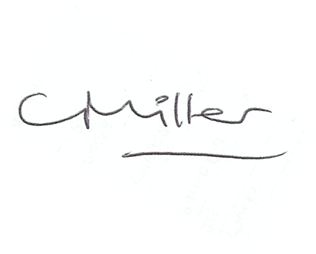
Claire Miller, Parish Clerk

