KIRKWHELPINGTON PARISH COUNCIL
AGENDA
You are hereby summoned to attend an ordinary meeting of Kirkwhelpington Parish Council to be held at the Memorial Hall, Kirkwhelpington on Tuesday 5th November 2019 commencing 730pm
2019/67 Apologies for Absence
2019/68 Declarations of Interest
2019/69 Meeting with energy advisor
2019/70 Public questions
2019/71 Minutes of previous meeting held Tuesday 3rd September 2019
2019/72 Matters arising from previous meeting held Tuesday 3rd September 2019
- Seat repair
- Play area/playing field fence
- Reflective posts
- Overgrown honeysuckle – to receive parishioner complaint regarding honeysuckle and overgrown shrubbery/grasscutting
- Grasscutting
- Garden waste service
- B4RN rural broadband
2019/73 Correspondence:
Community Foundation – Playing field grant
2019/74 Finance
2019/74/01 Bank Balance: £16012.76 as at 31/10/19
2019/74/02 The following accounts require authorisation:
- Kirkwhelpington Memorial Hall – W/C maintenance - £255.50;
- C Miller – September, October salary and expenses – £
- HMRC - PAYE on above - £57.20
- Robson & Cowan – £63.10 - petrol
- 2019/73/03 To receive request for grant from Sport Tynedale; Tynedale Hospice at Home; Community Action Northumberland
2019/74/03 To approve precept requirements 2020-2021
2019/74/04 Additional bank signatory
2019/74/05 To receive grant request from Community Action Northumberland; Citizens Advice Northumberland
2019/75 Planning Matters
2019/75/01 Planning Applications received
- 19/04041/VARYCO: Land East of Eastlands
2019/75/02 Consultation on smart metering base stations
2019/75/03 Wannies Ascension sculpture
2019/76 Wildlife and Countryside Act 1981 – Pre-order consultation
2019/77 Update on Ray Fell Wind Farm/Community Interest Company
Underground heating proposals; Feasibility study regarding engaging with youths; floral scheme
2019/78 Request from PCC to place Christmas tree on green
2019/79 Urgent Business
2019/80 Date of next Meeting
Dated this 26th day of October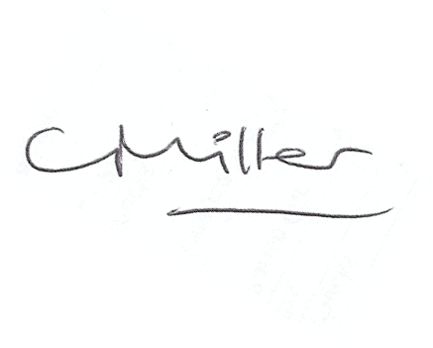
Claire Miller, Parish Clerk

