KIRKWHELPINGTON PARISH COUNCIL
AGENDA
You are hereby summoned to attend an ordinary meeting of Kirkwhelpington Parish Council to be held at the Memorial Hall, Kirkwhelpington on Tuesday 3rd September 2019 commencing 730pm
2019/54 Apologies for Absence
2019/55 Declarations of Interest
2019/56 Co-Option Vacancy
2019/57 Public questions
2019/58 Minutes of previous meeting held Tuesday 2nd July 2019
2019/59 Matters arising from previous meeting held Tuesday 2nd July 2019
- Trees
- Seat repair
- Purchase of goalposts
- Play area repairs
- Reflective posts
- Overgrown honeysuckle
2019/60 Correspondence:
- Acknowledgement of grant – PCC of Kirkwhelpington & Kirkharle
- CPRE – newsletter
- Northumberland Age UK
- Northumberland County Council – Waste leaflets & stickers
- Northumberland County Council – notice of 6th Annual Town & Parish Council Conference

2019/61 Finance
2019/61/01 Bank Balance: £13719.93 as at 30/08/19
2019/61/02 The following accounts require authorisation:
- W A Graham & Sons – drainage works - £3879
- Live4Soccer – football nets - £1179.95
- Kirkwhelpington Memorial Hall – W/C maintenance - £255.50;
- C Miller – July, August salary and expenses – £284.31 (inc payment to N/Estates below)
- HMRC - PAYE on above - £57.20
- Robson & Cowan – £57.38 – grasscutting expenses – £49.19 - fuel
- Northumberland Estates – rent payable village green, 2.2.18 to 1.2.19, £10.00
- PKF Littlejohn – audit fee – £240.00
- Northumberland & Newcastle Society – 2019 membership - £30.00
2019/61/03 To receive payment of £2620.00 from Karbon Homes and £694 from County Council towards wall works/drainage works
2019/61/04 To receive notice of conclusion of audit year ending 31/3/19
2019/61/05 Additional bank signatory

2019/62 Planning Matters
2019/62/01 Planning Applications received
- 19/02107/FUL: First floor extension, Wanneylaw
- 19/02072/FUL: Development of two two storey detached dwellings with ancillary garages and associated access roads, land to the South East of The Green, Kirkwhelpington
2019/62/02 Approval of Planning Application received
2019/62/03 Wannies Ascension sculpture
2019/62/04 Discharge of Condition, 19/01766/DISCON, Land East of Eastlands

2019/63 Update on Ray Fell Wind Farm/Community Interest Company
Underground heating proposals; Feasibility study regarding engaging with youths; floral scheme; proposed bus shelter

2019/64 Local Transport Plan Programme 2020-21
2019/65 Urgent Business
2019/66 Date of next Meeting
Dated this 23rd day of August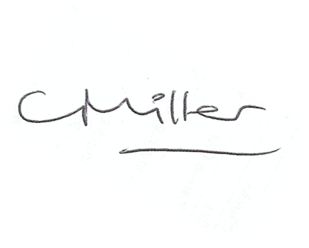
Claire Miller, Parish Clerk

