KIRKWHELPINGTON PARISH COUNCIL
AGENDA
You are summonsed to attend the annual meeting of the Parish Council to be held at 730pm on Tuesday 11th May 2021 in St Bartholomew’s Church
2021/32 Apologies for Absence

2021/33 Election of Chairman and Vice Chairman

2021/34 Declarations of Interest

2021/35 Public questions

2021/36 Minutes of previous meeting held Tuesday 2nd March 2021

2021/37 Matters arising from previous meeting held Tuesday 2nd March 2021
- Seat repair
- B4RN rural broadband
- Flooding at Hollyburn and A696
- Knowesgate traffic control
- Grasscutting
- Tree works at entrance to Meadowlands car park and tree on corner near to small ford
- Strengthening of village entrances
- Environmental proposals

2021/38 Correspondence
County Council – findings from Library Consultation
https://northumberland.moderngov.co.uk/documents/s2141/Public%20Library%20Service%20Consultation.pdf
https://northumberland.moderngov.co.uk/documents/s2143/App%202.pdf

2021/39 Finance
2021/39/01 Bank Balance: £19267.14 as at 30/04/21
2021/39/02 The following payments are to be authorised:
- Kirkwhelpington Memorial Hall – W/C maintenance - £255.50;
- C Miller – March, April salary/expenses - £263.02
- HMRC – PAYE on above - £58.60
- Robson & Cowan – postcrete - £20.84; fuel - £64.74
- NALC – annual subscription fee - £98.70
- Came & Company – annual insurance premium - TBC
2021/39/03 Acknowledgement of grant received from Citizens Advice Northumberland

2021/40 Planning Matters
2021/40/01 Planning Applications received
- 20/04394/VARYCO: Land East of Eastlands – Variation of Condition 8 to 19/04041/VARYCO in order to amend boundary fence detail

2021/40/02 Approval of Planning Application received

2021/40/03 To receive update on Eastlands Development
- Notice of withdrawal of planning application 20/03721/ADE, Land at entrances, advertisement consent for 2 V board signs and 1 single sign

2021/41 Update on Ray Fell Wind Farm/Community Interest Company
2021/41/01 To discuss bus shelter proposal

2021/42 Audit of Accounts year ending 31/3/21
2021/42/01 To consider and agree any actions arising from the report of the internal auditor
2021/42/02 To approve the Governance Statement
2021/42/03 To approve the draft annual accounts for 2020/2021
2021/42/04 To approve the Accounting Statement and explanation of variances
2021/42/05 To approve the Exemption Certificate
2021/42/06 To approve public right of inspection dates

2021/43 Urgent Business

2021/44 Date of next Meeting

3rd May 2021 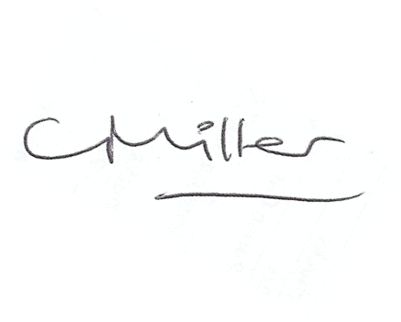
Claire Miller, Parish Clerk

KIRKWHELPINGTON PARISH COUNCIL
RISK ASSESSMENT FOR RESUMING FACE-TO-FACE MEETINGS

Risk | Description of Risk | Mitigation Measures
1.Room Set up and Dismantling | Transmission from setting out the chairs to hold the meeting. | Chairs and surfaces, eg door handles to be sanitised after use – members to sanitise their own chairs; Clerk/Chairman to undertake sanitisation on other areas.
2. Entering and leaving meeting | Close proximity to other members and the public entering and leaving the meeting and contact with doors. | Members to enter the meeting and leave in an orderly socially distanced way.  Hands to be sanitised on arrival.  Controlled, socially distanced, one by one, entry by other attendees.
3. Meeting Environment | Transmission through air and touch. | Socially distanced seating arrangement.  Windows and doors to be left open to facilitate the free flow of air though the meeting room.
5. Conduct of Meeting | Transfer through touch and air | Members and public to remain socially distanced at all times.  Wearing of masks except when speaking.  Shouting to be avoided.  The circulation of paper documents to be suspended.
6. Wider Issues | Members do not feel safe attending face to face meetings. | Members to stand when addressing the meeting so their voices will carry better.  Need to keep meeting “moving” so it does not last longer than necessary.
 | Track & trace | Contact details of any members of the public attending to be taken.

Risk Assessment for Face to Face meetings
May 2021
.

