KIRKWHELPINGTON PARISH COUNCIL
AGENDA
You are summonsed to attend a meeting of the Parish Council to be held at 730pm on Tuesday 6th July 2021 in Kirkwhelpington Memorial Hall, for the purpose of transacting the business contained within this Agenda. The public are welcome to observe.
2021/45 Apologies for Absence

2021/46 Declarations of Interest

2021/47 Public questions

2021/48 Minutes of previous meeting held Tuesday 11th May 2021

2021/49 Matters arising from previous meeting held Tuesday 11th May 2021
- B4RN rural broadband
- Grasscutting
- Tree works at entrance to Meadowlands car park and tree on corner near to small ford
- Strengthening of village entrances
- Environmental proposals
- Tree planting scheme
- Children playing signage

2021/50 Correspondence

2021/51 Finance
2021/51/01 Bank Balance: £20184.45 as at 30/06/21
2021/51/02 The following payments are to be authorised:
- Kirkwhelpington Memorial Hall – W/C maintenance - £255.50;
- C Miller – May, June salary/expenses - £285.80
- HMRC – PAYE on above - £58.80
- Robson & Cowan – £99.54 – repairs to Husqvarna
- RoSPA – annual play area inspection - £107.40

2021/52 Planning Matters
2021/52/01 Planning Applications received
2021/52/02 Approval of Planning Application received
2021/52/03 To receive update on Eastlands Development
2021/52/04 Northumberland Local Plan Examination – Consultation on Main Modifications

2021/53 Update on Ray Fell Wind Farm/Community Interest Company
2021/53/01 Proposed bus shelter at Knowesgate
2021/53/02 Improvement to lighting at bus shelter in Kirkwhelpington

2021/54 Wildlife & Countryside Act, 1981: Review of the Definitive Map and Statement of Public Rights of Way, Informal pre-order consultation

2021/55 St Oswald’s Way Footpaths and walker’s safety

2021/56 To consider findings from Annual RoSPA Play Area Inspection Report

2021/57 Urgent Business

2021/58 Date of next Meeting

25th June 2021 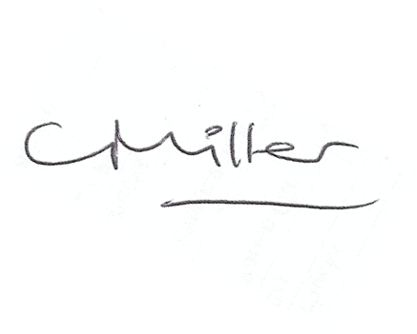
Claire Miller, Parish Clerk

