Minutes of meeting of Kirkwhelpington Parish Council held at the Memorial Hall, Kirkwhelpington on Tuesday 7th of March 2017 at 7.30pm,
Those Present: Cllr Thornton, Cllr A Purves, Cllr P Senior, J Brown, K Fortune, C Miller (Clerk), two members of the public
2017/15 Apologies for Absence
Cllr E Rogerson

2017/16 Declarations of Interest
There were no Declaration of Interests.

2017/17 Public questions
It was Two Castles understanding, who had confirmed in writing to residents, that drainage had not been placed in field, with proposals to carry out improvements. Parishioners had also requested independent quotes for wall repair to Meadowlands, which were considerably cheaper compared to the Housing Association quote. As regards playing field land responsibilities, Parish Council are taking legal advice through Northumberland Association of Local Councils.

2017/18 Sulphur Well
Further comments had been received by The Planning Inspectorate, with copies forwarded to Parish Council.

2017/19 Minutes of previous meeting
The minutes of the previous meeting were agreed as a true record.

2017/20 Matters arising from previous meeting
- Request for slow signs and signs to indicate Horses to be added to Local Transport Plan requests.
- County Council had stated 40mph signage at Knowesgate would not be appropriate, however proposed scheme is to be implemented in next financial year and will continue to be monitored, with anticipation the proposals will result in an improvement to the current situation.
- Soil had been removed from play area, and it was agreed a contribution of £100 would be made to D Pearson for arranging this.
- Ongoing problems with flooding on A696.

2017/21 Youth Club
Nothing to report.

2017/22 Correspondence
- CAN – Getabout Access Scheme – scheme relating to persons with transport difficulties.
- C Dilger – overhanging trees/Vodafone mobile coverage – referring to church trees shading the garden of The Old School dwelling – it was agreed to inform C Dilger the PC would officially write to the PCC regarding trees, however the problems with Vodafone were national and not a matter the Parish Council could assist with.

2017/23 Finance
2017/23/01 Bank Balance: £4277.97 as at 28/02/17
2017/23/02 The following invoices were authorised for payment
- Kirkwhelpington Memorial Hall – W/C maintenance - £255.50
- C Miller – January, February salary and expenses - £248.25
- HMRC - PAYE on above - £53.20
- Northumberland Estates – rent in arrears 2/2/17 to 1/2/17 - £5.25
- D Pearson – soil removal - £100.00

2017/24 Planning Matters
2017/24/01 Planning Applications received:
- 17/00026/PRUTPO: Clairley Kirkwhelpington – tree pruning – proposals supported.

2017/24/02 Approval of Planning Application
- 17/00026/PRUTPO: Clairley Kirkwhelpington – tree pruning.

2017/25 Play Ground
Goalpost maintenance outstanding.

2017/26 Annual review of Risk Assessment/Internal Auditor
Document had been circulated to all and it was agreed sufficient for the present needs of Kirkwhelpington Parish Council. Clerk to contact internal auditor who had carried out 2015-2016 audit and confirm the PC wished to re-engage them.

2017/27 Ray Fell Wind Farm/Community Benefit Fund
Plan to hold public meeting at Kirkwhelpington Memorial Hall during March with information to be displayed regarding grants available. There would be a small grants application fund of £100K/year for grants up to £10K; a further band of funding for major grants, such as all parishioners being linked up to superfast broadband; and an endowment fund to be set up for accessing funds after the life of the wind farm.

2017/28 Urgent Business
- Cllr P Senior to construct new window for bus shelter.
- Further to chimney sweep visiting the village, problems occurring due to disorganisation of ISOS, as well as other issues involving work to properties. Instances to be forwarded to Clerk for comment to ISOS.
- Verges when entering village becoming increasingly churned up due to wagons/buses, Clerk to report to County Council, and Cllrs Senior and Fortune to carry out remedial works.

2017/29 Information Items
- City and County newsletter
- Northumberland County Council – Residents Festival

2017/30 May 2017 Elections
Process of applying to carry on as a Cllr explained.

2017/31 Date of next Meeting
The next meeting of Kirkwhelpington Parish Council will be held on Tuesday 9th May 2017 commencing after the Annual Parish Meeting commencing at 7pm.
The meeting closed at 915pm
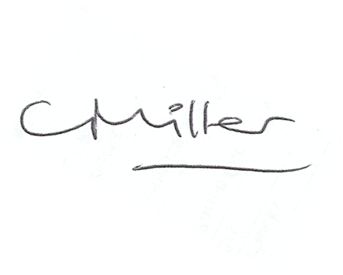
Claire Miller
Parish Clerk

www.parish-council.com/kirkwhelpington

