THROPTON PARISH COUNCIL
AGENDA PAPER

You are hereby summoned to an ordinary meeting of Thropton Parish Council to be held on Tuesday 21st March 2023 commencing at 7pm in Thropton War Memorial Hall, for the purpose of transacting the business contained within this agenda.
2023/15 Apologies for absence

2023/16 Declaration of Members Interests

2023/17 Public Questions

2023/18 Minutes of previous meeting held Tuesday 17th January 2023

2023/19 Thropton Play Area
2023/19/01 To consider most recent play area inspection reports
2023/19/02 To consider quotation(s) for play area grasscutting

2023/20 To consider Traffic control/traffic calming proposals for the parish

2023/21 Finance
2023/21/01 Invoices for authorisation:
- Jubilee Institute – meeting room hire – Coquetdale Cluster Meeting 6/12/22 - £8.00
- C Miller – six monthly salary, expense - £598.91
- HMRC – PAYE - £145.20
- Glasdon – replacement litter bin – £243.88

2023/21/02 To consider request for litter bin near to Spar

2023/22 Planning
2023/22/01 Planning Applications received
- 23/00647/FUL: Overwreigh, Overwreigh Lane, Additional works to 21/01603/FUL comprising of flat roof addition to rear of proposed single storey pitched roof extension to side of property
2023/22/02 Approval of planning application received

2023/23 To receive update from Rothbury Joint Burial Committee

2023/24 To consider Crises Management

2023/25 To consider Climate Change

2023/26 Review of Internal Auditor
2023/27 Review of Internal Controls
2023/28 Review of Insurance Policy
2023/29 Review of Asset Register
2023/30 Review of Risk Assessment

2023/31 To consider parishioner report of road flooding within the parish

2023/32 To consider parishioner correspondence relating to reducing the villages dependence on heating fuel and expensive electricity

2023/33 To consider Coronation celebration/party in the parish

2023/34 To consider proposal from Thropton Parish Cllr Ray Aplin to request an increase in the X14 bus service and for proposals to be forwarded to Northumberland County Council, North of Tyne Combined Authority, Transport North East and Arriva
2023/35 Date of next meeting

Dated this 13th day of March 2023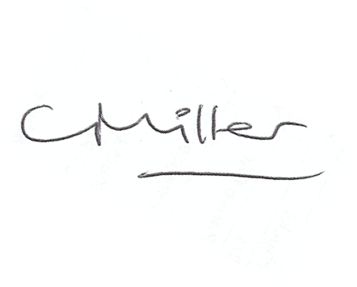
Claire Miller
Parish Clerk
www.parish-council.com/thropton

