Minutes of electronic meeting of Thropton Parish Council held at 715pm on Monday 9th November 2020
Those Present: Cllr Foggon (Chairman), Cllr J Carr, Cllr J Sutton, Cllr I Webb, C Miller (Clerk)
2020/61 Apologies for absence
Cllr D Oliver

2020/62 Declaration of Members Interests
There were no declaration of members interests.

2020/63 Public Questions
The village had proposed a Christmas lights event to cheer the parish up with residents to display lights in their homes. A verbal request for funding had been submitted to the Parish Council, however any funding request would need to be received in writing, be a detailed agenda item, and any funds granted could only be paid to a constituted committee.

2020/64 Police Report
There was no police report. Fighting Crime Preventing Crime Survey available on Northumbria Crime and Police Commissioner web-site. Commissioner had attended Coquetdale Cluster meeting held in October and was keen for as many people as possible to complete the on-line survey. An incident with a wagon at the Cross Keys bank had occurred last week which had caused considerable congestion and which could not be reported on-line or by dialling 111, with police taking two hours to attend the incident.

2020/65 Minutes of previous meeting held Monday 14th September 2020
It was resolved the minutes of the previous meeting held on Monday 14th September 2020 be accepted as a true record.

2020/66 Matters arising from previous meeting held Monday 14th September 2020
- Street Lighting at Sylvan Cottage: Nothing to report.
- Village nameplates: Other parishes seemed to obtain new village signage and Clerk would contact County Council to enquire how Thropton could possibly obtain this.
- Parking and speeding issues within the parish: Numerous complaints had been received regarding parking and speeding in the parish, however parishioners could be contributing to the issue by problematic parking on pavements. Cllr I Webb to create a report indicating the problems with speeding and parking in the parish. Further to discussion at previous meeting regarding danger signage for drivers to advise of children playing, County Council had advised such signage could only be used where there are formal playgrounds, not just in general, and drivers are expected to know that they could encounter children playing in any built-up area.
- Footpath works from bridge to school: Works still not completed - Clerk to chase up.

2020/67 Finance
2020/67/01 The following accounts are to be approved:
- Kidd Garden Design – grasscutting/play area – no invoice received.
- Longstaff Tree Surgery – treeworks - £995
It was resolved to approve the payments.

2020/67/02 To consider grant request from Northumberland AgeUK
Information had been received regarding Northumberland AgeUk and which would be displayed in noticeboard,
however no official grant request had been received.

2020/67/02 To receive update on repairs required at play area
Repairs had been completed by gardener.

2020/67/03 To consider budget and precept requirements for 2021-2022
First draft of budget and precept requirements for 2021-2022 discussed, with Clerk advising the precept should be raised to £4,000 in order to increase the play area reserve amount to £2,000. Final figures would be confirmed at the next meeting, when figures confirming the Thropton precept towards Rothbury cemetery would be advised.

2020/68 Planning
2020/68/01 Planning Applications received
No planning applications had been received.

2020/68/02 Mid Coquetdale Neighbourhood Plan – to receive update on resurrection of project and approve financial contribution of £1017.28 previously refunded to TPC when plan put into abeyance
It was resolved the funds would be authorised for return to RPC bank account. Further informal meeting was to be held on Monday 16th November 2020 commencing 6pm, with a Planning Officer from County Council to be in attendance to offer support and guidance. Cllr I Webb to attend.

2020/69 Correspondence
No correspondence had been received.

2020/70 To consider issues of concern within the parish
Cllr I Webb raised the matter of the incident with the wagon at Cross Keys bank, however County Council had attended site shortly after the incident and were well aware of the damage that had occurred.

2020/71 Date of next meeting
The next meeting of Thropton Parish Council will be held on Monday 12th January 2021 commencing 715pm.
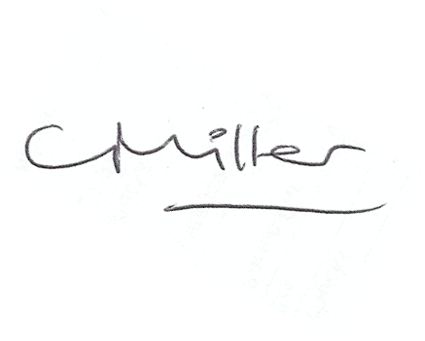
C Miller Parish Clerk

The meeting closed at 8pm.

www.parish-council.com/thropton

