WALLINGTON DEMESNE PARISH COUNCIL
AGENDA PAPER
You are hereby summoned to attend a meeting of Wallington Demesne Parish Council to be held at Cambo Village Hall on Monday 25th July 2016 commencing 730pm, for the purpose of transacting the business contained within this Agenda

2016/42 Apologies for absence
2016/43 Minutes of the meeting held on 23rd May 2016

2016/44 Matters arising from the minutes
- Parking at Cambo

2016/45 Public questions: members of the public can attend and speak on any matter on the agenda

2016/46 NCC Update

2016/47 Police Update

2016/48 Reports from representatives at outside meetings

2016/49 Financial Matters
2016/49/01 Invoices for authorisation
- National Trust – rent for football pitch - £180
- Middleton & Todridge Village Hall – hire of hall 23/5/16 - £20.00
- C Miller – six monthly salary & expenses £1154.28
- HMRC – PAYE on above – E7.00

2016/49/02 Any other financial issues

2016/50 Planning Applications
2016/50/01 Planning Applications received
2016/50/02 Approval of Planning Application received

2016/51 Neighbourhood Management
2016/51/01 Wallington Bridge, Masonry Arch Refurbishment
2016/52 Correspondence
- Northumberland County Council – final consultation Core Strategy
- Northumberland County Council – Cambo War Memorial
- H Tinegate – defibrillator
- Northumberland County Council – Local Transport Plan Requests 2017-2018

2016/53 Urgent Business
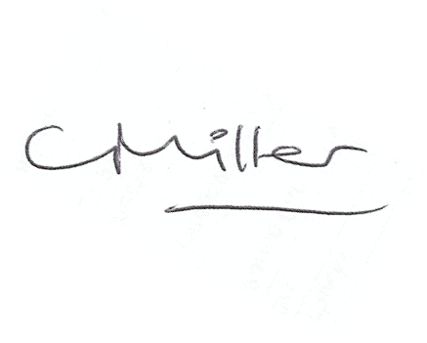
Claire Miller
Parish Clerk

www.parish-council.com/wallingtondemesne/

