WALLINGTON DEMESNE PARISH COUNCIL
AGENDA PAPER
You are hereby summoned to attend a meeting of Wallington Demesne Parish Council to be held at Cambo Village Hall on Monday 28th November 2016 commencing 730pm, for the purpose of transacting the business contained within this Agenda

2016/68 Apologies for absence
2016/69 Minutes of the meeting held on 26th September 2016
2016/70 Declaration of Interests
2016/71 Vacancy
2016/72 Matters arising from the minutes
- Parking at Cambo
- Defibrilators
- Cambo seat

2016/73 Public questions: members of the public can attend and speak on any matter on the agenda

2016/74 NCC Update

2016/75 Police Update

2016/76 Reports from representatives at outside meetings

2016/77 Financial Matters
2016/77/01 Invoices for authorisation: Defibrillator costs
2016/77/02 To discuss/agree precept 2017 - 2018

2016/78 Planning Applications
2016/78/01 Planning Applications received
2016/78/02 Approval of Planning Application received

2016/79 Neighbourhood Management
2016/79/01 Wallington Bridge, Masonry Arch Refurbishment

2016/80 Correspondence
- Northumberland County Council – Core Strategy final consultation – relating to Ponteland/Morpeth

2016/81 Urgent Business
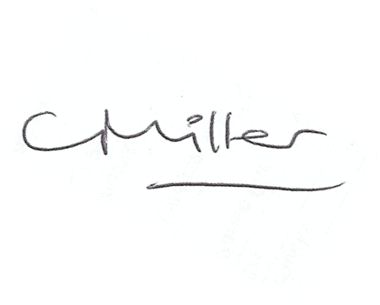
Claire Miller
Parish Clerk

www.parish-council.com/wallingtondemesne/

