WALLINGTON DEMESNE PARISH COUNCIL
NOTICE OF MEETING
The Annual Meeting of the Parish of Wallington Demesne will be held in Middleton Village Hall on Monday 23rd May 2016 commencing 7pm
The agenda will be as follows:
- Apologies for absence
- Minutes of the meeting held 18th May 2015
- Matters arising from the minutes
- Any Other Business

WALLINGTON DEMESNE PARISH COUNCIL
AGENDA PAPER
You are hereby summoned to attend the Annual General meeting of Wallington Demesne Parish Council to be held at Middleton Village Hall on Monday 23rd May 2016 commencing 730pm, for the purpose of transacting the business contained within this Agenda
2016/29 Appointment of Chairperson and Vice Chairperson
2016/30 Apologies for absence
2016/31 Minutes of the meeting held on 21st March 2016
2016/32 Matters arising from the minutes
2016/33 NCC Update
2016/34 Police Update
2016/35 Reports from representatives at outside meetings
2016/36 Financial Matters
2016/36/01 Invoices for authorisation
2016/36/02 Audit of Accounts year ending 31/3/16
2016/36/03 Any other financial issues
2016/37 Planning Applications
2016/37/01 Planning Applications received
2016/37/02 Approval of Planning Application received
2016/38 Neighbourhood Management
2016/38/01 Wallington Bridge, Masonry Arch Refurbishment
2016/39 Correspondence
2016/40 Local Housing
2016/41 Urgent Business
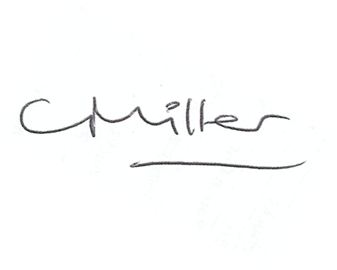
Claire Miller
Parish Clerk

