WALLINGTON DEMESNE PARISH COUNCIL
AGENDA PAPER

You are hereby summoned to attend an ordinary meeting of Wallington Demesne Parish Council to be held at Cambo Village Hall on Monday 23rd July 2018 commencing 730pm, for the purpose of transacting the business contained within this Agenda

2018/51 Apologies for absence
2018/52 Declarations of Members interests
2018/53 Opportunity for members of the public to raise any matter on the agenda
2018/54 Minutes of the meeting held on 21st May 2018
2018/55 Matters arising from previous minutes held on 21st May 2018
- Defibrillators for Cambo and Scots Gap – to approve Parish Council contribution of £1450 towards machinery
- Fibre optic broadband
- Dog fouling at Cambo
- Safety checks at Cambo burial ground
2018/56 NCC Update
2018/57 Police Update
2018/58 Reports from representatives at outside meetings
- Cambo School:
- Cambo Village Hall: to approve Parish Council representative
- Middleton Hall
- Wallington F.C.
2018/59 Financial Matters
2018/59/01 Payments for authorisation:
- C Miller – June, July salary & expenses – £334.45
- HMRC – PAYE on above - £74.00
- NALC – annual membership - £90.71

2018/59/02 To discuss and agree request for Grant from Wallington F.C.

2018/60 Planning
2018/60/01 Planning Applications received
2018/60/02 Approval of Planning Application received
2018/60/03 Northumberland Local Plan Consultation

2018/61 Neighbourhood Management – to report on any issues within the parish
2018/62 Correspondence
- Request for reduction in speed limit for Cambo; warning signage for children playing and ”no through road signage, residents only” at front row
2018/63 Local Transport Plan feedback 2018-19 and Local Transport Plan requests 2019-20
2018/65 Adoption of documents relating to General Data Protection Regulations (GDPR): Information & Data Protection Policy; Publication Scheme and Councillor Details; Subject Access Request Form; Privacy Notice; Email Contact Privacy Notice; Councillor Privacy Notice; Document Retention Policy; exclusive rights of burial privacy notice
2018/66 Consultation on Northumberland County Council Statement of Principles 2019-2022

2018/67 Urgent Business
2018/68 Date of Next Meeting
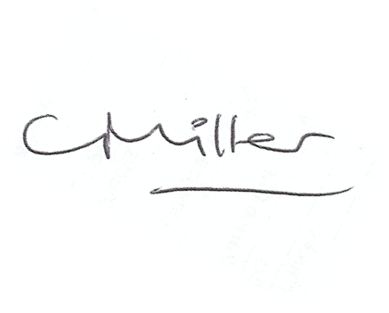
Claire Miller
Parish Clerk

