WALLINGTON DEMESNE PARISH COUNCIL
NOTICE OF MEETING
The Annual Meeting of the Parish of Wallington Demesne will be held in Middleton Village Hall on Thursday 21st May 2018 commencing 7pm
The agenda will be as follows:
- Apologies for absence
- Minutes of the meeting held 11th May 2017
- Matters arising from the minutes
- Public participation
- Any Other Business

WALLINGTON DEMESNE PARISH COUNCIL
AGENDA PAPER

You are hereby summoned to attend the annual meeting of Wallington Demesne Parish Council to be held at Middleton Village Hall on Monday 21st May 2018 commencing 730pm, for the purpose of transacting the business contained within this Agenda

2018/32 Apologies for absence
2018/33 Election of Chairman
2018/34 Election of Vice Chairman
2018/35 Election of representatives at outside bodies
2018/36 Declarations of Members interests
2018/37 Opportunity for members of the public to raise any matter on the agenda
2018/38 Minutes of the meeting held on 26th March 2018
2018/39 Matters arising from previous minutes held on 26th March 2018
- Defibrillators for Cambo and Scots Gap
- Fibre optic broadband
- Dog fouling at Cambo
- Safety checks at Cambo burial ground
2018/40 NCC Update
2018/41 Police Update
2018/42 Reports from representatives at outside meetings
- Cambo School
- Cambo Village Hall
- Middleton Hall
- Wallington F.C.
2018/43 Financial Matters
2018/43/01 Invoices for authorisation:
- C Miller – April, May salary & expenses – £350.95
- HMRC – PAYE on above - £74.00
- Cambo Village Hall - £6.00
- Annual insurance premium

2018/43/02 To discuss and agree request for Grants from the following:
- Wallington F.C.
2018/44 Audit of Accounts year ending 31/3/18
2018/44/01 To review the effectiveness of the system of internal control and consider the findings
2018/44/02 To consider and agree any actions arising from the report of the internal auditor
2018/44/03 To approve the Governance Statement
2018/44/04 To approve the draft annual accounts for 2017/2018
2018/44/05 To approve the Accounting Statement and explanation of variances
2018/44/06 To confirm and approve the Certificate of Exemption

2018/45 Planning Applications
2018/45/01 Planning Applications received
- 18/00745/LBC: Mr P Foley, Highlaws Farm, Hartburn – internal alterations
2018/45/02 Approval of Planning Application received
2018/46 Neighbourhood Management – to report on any issues within the parish
2018/47 Correspondence
- Northumberland County Council – Love Northumberland Awards 2018
- Northumberland County Council – weed control
- Northumberland County Council, road hierarchy consultation
- CPRE, newsletter

2018/48 To receive/discuss information relating to General Data Protection Regulations (GDPR)
2018/49 Urgent Business
2018/50 Date of Next Meeting
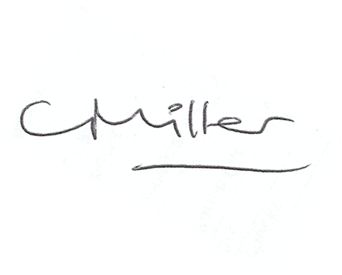
Claire Miller
Parish Clerk

