WALLINGTON DEMESNE PARISH COUNCIL
AGENDA PAPER

You are hereby summoned to attend an ordinary meeting of Wallington Demesne Parish Council to be held at Cambo Village Hall on Monday 26th November 2018 commencing 730pm, for the purpose of transacting the business contained within this Agenda

2018/84 Apologies for absence
2018/85 Declarations of Members interests
2018/86 Opportunity for members of the public to raise any matter on the agenda
2018/87 Minutes of the meeting held on 24th September 2018
2018/88 Matters arising from previous minutes held on 24th September 2018
- Defibrillators for Cambo and Scots Gap
- Fibre optic broadband
- Dog fouling at Cambo
- Cambo traffic/Signage at Front Row, Cambo

2018/89 NCC Update
2018/90 Police Update
2018/91 Reports from representatives at outside meetings
- Cambo School
- Cambo Village Hall
- Middleton Hall
- Wallington F.C.

2018/92 Financial Matters
2018/92/01 Payments for authorisation:
- C Miller – October, November salary & expenses – £327.28
- HMRC – PAYE on above - £74.00
2018/92/02 Grant request received:
- Community Action Northumberland
2018/92/03 Approval of precept 2019-2020

2018/93 Planning
2018/93/01 Planning Applications received
2018/93/02 Approval of Planning Application received
2018/94 Neighbourhood Management – to report on any issues within the parish
2018/95 Correspondence
- CPRE – newsletter
- Priority signage for Wallington Bridge
2018/96 Urgent Business
2018/97 Meeting dates 2019
- Monday 28 January – Middleton
- Monday 25 March – Cambo
- Monday 20 May – Middleton
- Monday 22 July – Cambo
- Monday 23 September – Middleton
- Monday 25 November - Cambo
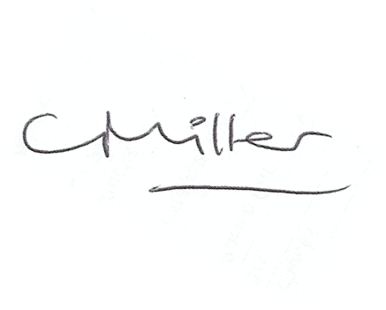
Claire Miller
Parish Clerk

