WALLINGTON DEMESNE PARISH COUNCIL
AGENDA PAPER

You are hereby summoned to attend an ordinary meeting of Wallington Demesne Parish Council to be held at Middleton Village Hall on Monday 24th September 2018 commencing 730pm, for the purpose of transacting the business contained within this Agenda

2018/69 Apologies for absence
2018/70 Declarations of Members interests
2018/71 Opportunity for members of the public to raise any matter on the agenda
2018/72 Minutes of the meeting held on 23rd July 2018
2018/73 Matters arising from previous minutes held on 23rd July 2018
- Defibrillators for Cambo and Scots Gap
- Fibre optic broadband
- Dog fouling at Cambo
- Signage at Front Row, Cambo

2018/74 NCC Update
2018/75 Police Update
2018/76 Reports from representatives at outside meetings
- Cambo School: to approve Parish Council representative
- Cambo Village Hall
- Middleton Hall
- Wallington F.C.

2018/77 Financial Matters
2018/77/01 Payments for authorisation:
- C Miller – August, September salary & expenses – £329.16
- HMRC – PAYE on above - £74.00
- Cambo Village Hall – rent 23/8/18 - £6.00

2018/78 Planning
2018/78/01 Planning Applications received
- 18/02989/LBC: Bolt Cottage, Wallington – refurbishment works
2018/78/02 Approval of Planning Application received

2018/79 Neighbourhood Management – to report on any issues within the parish
2018/80 Correspondence
- County Council – disposing of hazardous waste
- County Council – notice of Annual Town and Parish Conference 11/10/18

2018/81 Local Transport Plan 2019-2020

2018/82 Urgent Business
2018/83 Date of Next Meeting
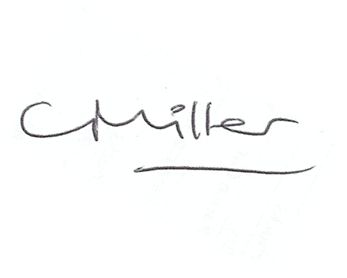
Claire Miller
Parish Clerk

