WALLINGTON DEMESNE PARISH COUNCIL
AGENDA PAPER
You are hereby summoned to attend a meeting of Wallington Demesne Parish Council to be held at Middleton Village Hall on Monday 22nd January 2018 commencing 730pm, for the purpose of transacting the business contained within this Agenda
2018/01 Apologies for absence
2018/02 Co-Option Vacancy
2018/03 Declarations of Members interests
2018/04 Opportunity for members of the public to raise any matter on the agenda
2018/05 Minutes of the meeting held on 21st November 2017
2018/06 Matters arising from previous minutes held on 21st November 2017
- Defibrillators for Cambo and Scots Gap; Fibre optic broadband; Dog fouling at Cambo
2018/07 NCC Update
2018/08 Police Update
2018/09 Reports from representatives at outside meetings
- Cambo School
- Cambo Village Hall
- Middleton Hall
- Wallington F.C.
2018/10 Financial Matters
2018/10/01 Invoices for authorisation:
- Cambo Village Hall - £12.00
- J Ballantine – hedgecutting - £100
- C Miller – December, January salary & expenses – £321.33
- HMRC – PAYE on above - £72.60
2018/10/02 To agree grant to Cambo First School towards school trip to London
2018/11 Planning Applications
2018/11/01 Planning Applications received
2018/11/02 Approval of Planning Application received
2018/12 Neighbourhood Management – to report on any issues within the parish
2018/13 Correspondence
- North of Tyne Devolution – Governance Review Consultation
- Northumberland County Council – parking survey

2018/14 Urgent Business
2018/15 Date of Next Meeting
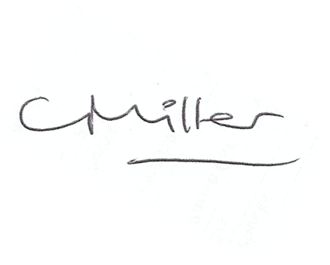
Claire Miller
Parish Clerk

