WALLINGTON DEMESNE PARISH COUNCIL
AGENDA PAPER
You are hereby summoned to attend a meeting of Wallington Demesne Parish Council to be held at Cambo Village Hall on Monday 26th March 2018 commencing 730pm, for the purpose of transacting the business contained within this Agenda
2018/16 Apologies for absence
2018/17 Co-Option Vacancy
2018/18 Declarations of Members interests
2018/19 Opportunity for members of the public to raise any matter on the agenda
2018/20 Minutes of the meeting held on 22nd January 2017
2018/21 Matters arising from previous minutes held on 22nd January 2017
- Defibrillators for Cambo and Scots Gap
- Fibre optic broadband
- Dog fouling at Cambo
2018/22 NCC Update
2018/23 Police Update
2018/24 Reports from representatives at outside meetings
- Cambo School
- Cambo Village Hall
- Middleton Hall
- Wallington F.C.
2018/25 Financial Matters
2018/25/01 Invoices for authorisation:
- Middleton Village Hall – rent for meeting held 22/1/18 - £20.00
- C Miller – February, March salary & expenses – £321.33
- HMRC – PAYE on above - £72.60
2018/25/02 To discuss and agree request for Grants from the following:
- Wallington F.C.
- Cambo Wraparound
2018/25/03 To review charges for Cambo burial ground
2018/25/04 To review insurance cover
2018/25/05 To review asset register
2018/25/06 To review internal auditor and system of internal control

2018/26 Planning Applications
2018/26/01 Planning Applications received
2018/26/02 Approval of Planning Application received
2018/27 Neighbourhood Management – to report on any issues within the parish
2018/28 Correspondence
- Middleton Village Hall – Summary of Accounts and Balance Sheet as at 31/12/17
- Northumberland County Council – Wallington, cycle warning signs
- Northumberland County Council – Post 16 Transport – to discuss consultation document
2018/29 To receive/discuss information relating to General Data Protection Regulations (GDPR
2018/30 Urgent Business
2018/31 Date of Next Meeting
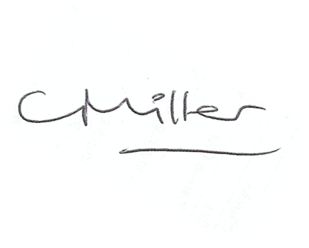
Claire Miller
Parish Clerk

