WALLINGTON DEMESNE PARISH COUNCIL
AGENDA PAPER

You are hereby summoned to attend an ordinary meeting of Wallington Demesne Parish Council to be held at Middleton Village Hall on Monday 28th January 2019 commencing 730pm, for the purpose of transacting the business contained within this Agenda

2019/01 Apologies for absence
2019/02 Declarations of Members interests
2019/03 Opportunity for members of the public to raise any matter on the agenda
2019/04 Minutes of the meeting held on Monday 26th November 2018
2019/05 Matters arising from previous minutes held on Monday 26th November 2018
- Defibrillators for Cambo and Scots Gap
- Fibre optic broadband
- Dog fouling at Cambo
- Speed Survey, Scots Gap
- Lampost at Oakford

2019/06 NCC Update
2019/07 Police Update
2019/08 Reports from representatives at outside meetings
- Cambo School
- Cambo Village Hall
- Middleton Hall
- Wallington F.C.

2019/09 Financial Matters
2019/09/01 Payments for authorisation:
- Cambo Village Hall - £6.00
- J Gledson – reimbursement of funding towards defibrillator at Cambo - £300
- C Miller – December, January salary & expenses – £329.19
- HMRC – PAYE on above - £74.00
- Middleton & Todridge Village Hall – rent of meeting room May/September 2018 - £40.00

2019/10 Planning
2019/10/01 Planning Applications received
2019/10/02 Approval of Planning Application received
2019/11 Neighbourhood Management – to report/update on action regarding issues within the parish
2019/12 Correspondence
- Confirmation of NJC payscales from 1/4/19
- Northumberland County Council – Roadside litter campaign 2018
- Northumberland Draft Local Plan – Consultation 30/1 to 13/3/19 regarding the soundness of the plan
- CPRE newsletter

2019/13 Urgent Business
2019/14 Date of Next Meeting
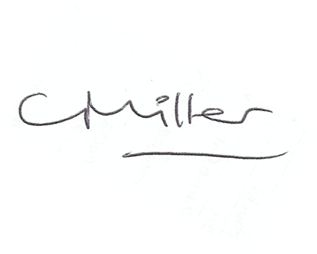
Claire Miller
Parish Clerk

