WALLINGTON DEMESNE PARISH COUNCIL
AGENDA PAPER

You are hereby summoned to attend an ordinary meeting of Wallington Demesne Parish Council to be held at Cambo Village Hall on Monday 22nd July 2019 commencing at 730pm, for the purpose of transacting the business contained within this Agenda

2019/48 Apologies for absence
2019/49 Declarations of Members interests
2019/50 Co-option Vacancies
2019/51 Opportunity for members of the public to raise any matter on the agenda
2019/52 Minutes of the meeting held on Monday 20th May 2019
2019/53 Matters arising from previous meeting held on Monday 20th May 2019
- Fibre optic broadband
- Lampost at Oakford
- Cambo seat
- Cambo school car park
- Defibrillator signage at Wallington
- Grasscutting, Oakford
2019/54 NCC Update
2019/55 Police Update
2019/56 Reports from representatives at outside meetings
- Cambo School
- Cambo Village Hall
- Middleton Hall
- Wallington F.C.

2019/57 Financial Matters
2019/57/01 Payments for authorisation:
- C Miller – June, July salary & expenses – £438.97
- HMRC – PAYE on above - £2.00
- National Trust – rent for football ground - £180.00
- Middleton & Todridge Village Hall – meeting room rent 20.5.19 - £20.00; defibrillator training 28.1.19 - £20.00
2019/58 Planning
2019/58/01 Planning Applications received
- 19/01703/LBC & 19/01704/LBC – Pele House, Cambo
- 19/01958/FUL – Construction of new garage/workshop building, old nursery track from Scots Gap to West Grange bungalow
- 19/02077/FUL – Single storey rear extension, replace flat roof, new cladding to part of existing property, old nursery, Scots Gap
2019/59 Neighbourhood Management – to report/update on action regarding issues within the parish
2019/60 Local Transport Plan Programme 2020-21
2019/61 Correspondence
- CPRE newsletter
- Ray Wind Funds – notice of public meeting 6/6/19
- County Council – Housing Strategy for Northumberland 2019-2021 Consultation
2019/62 Urgent Business
2019/63 Date of Next Meeting
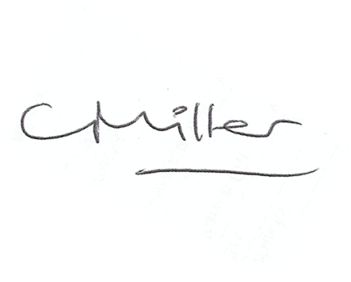
Claire Miller
Parish Clerk

