WALLINGTON DEMESNE PARISH COUNCIL
AGENDA PAPER

You are hereby summoned to attend an ordinary meeting of Wallington Demesne Parish Council to be held at Cambo Village Hall on Monday 25th March 2019 commencing 730pm, for the purpose of transacting the business contained within this Agenda

2019/15 Apologies for absence
2019/16 Declarations of Members interests
2019/17 Opportunity for members of the public to raise any matter on the agenda
2019/18 Minutes of the meeting held on Monday 28th January 2019
2019/19 Matters arising from previous minutes held on Monday 28th January 2019
- Fibre optic broadband
- Dog fouling at Cambo
- Speed Survey, Middleton
- Lampost at Oakford
- Defibrillators

2019/20 NCC Update
2019/21 Police Update
2019/22 Reports from representatives at outside meetings
- Cambo School
- Cambo Village Hall
- Middleton Hall – to approve Parish Council submit planning application for Middleton Hall extension to County Counci
- Wallington F.C.

2019/23 Financial Matters
2019/09/01 Payments for authorisation:
- Imperative Training Ltd – defibrillator pads - £52.80
- C Miller – December, January salary & expenses – £329.60
- HMRC – PAYE on above - £74.00
2019/19/02 Request for grant received from North East War Memorials Project

2019/24 Planning
2019/24/01 Planning Applications received
2019/24/02 Approval of Planning Application received
2019/25 Neighbourhood Management – to report/update on action regarding issues within the parish
2019/26 Correspondence
- J Gledson – Cambo defibrillator

2019/27 Review of Internal Auditor/internal controls; Asset Register; Risk Assessment and Insurance Policy

2019/28 Urgent Business
2019/29 Date of Next Meeting
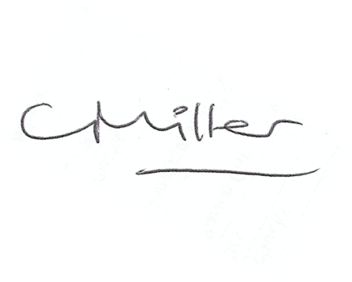
Claire Miller
Parish Clerk

