WALLINGTON DEMESNE PARISH COUNCIL
NOTICE OF MEETING
The Annual Meeting of the Parish of Wallington Demesne will be held in Middleton Village Hall on Monday 20th May 2019 commencing 7pm
The agenda will be as follows:
- Apologies for absence
- Minutes of the meeting held 21st May 2018
- Matters arising from the minutes
- Public participation
- Any Other Business

WALLINGTON DEMESNE PARISH COUNCIL
AGENDA PAPER

You are hereby summoned to attend an ordinary meeting of Wallington Demesne Parish Council to be held at Middleton Village Hall on Monday 20th May 2019 commencing after the Annual Parish Meeting at 7pm, for the purpose of transacting the business contained within this Agenda

2019/30 Apologies for absence

2019/31 Declarations of Members interests

2019/32 Election of Chairman

2019/33 Election of Vice Chairman

2019/34 Election of representatives on outside bodies

2019/35 Opportunity for members of the public to raise any matter on the agenda

2019/36 Minutes of the meeting held on Monday 25th March 2019

2019/37 Matters arising from previous meeting held on Monday 25th March 2019
- Fibre optic broadband
- Lampost at Oakford
- Cambo seat
- Cambo school car park

2019/38 NCC Update

2019/39 Police Update

2019/40 Reports from representatives at outside meetings
- Cambo School
- Cambo Village Hall
- Middleton Hall
- Wallington F.C.

2019/41 Financial Matters
2019/41/01 Payments for authorisation:
- C Miller – February, March salary & expenses – £410.57
- HMRC – PAYE on above - £1.80
- Cambo Village Hall - £9.00
- Came & Co – annual insurance premium - £218.00
- Middleton & Todridge Village Hall - £40.00
- NALC – annual subscription - £93.99
- The Stephen Carey Fund – defib pads - £42.90

2019/42 Planning
2019/42/01 Planning Applications received
2019/42/02 Approval of Planning Application received
2019/43 Neighbourhood Management – to report/update on action regarding issues within the parish
- Speed survey at Wallington

2019/44 Correspondence
- CPRE newsletter
- Ray Wind Funds – notice of public meeting 6/6/19
- County Council – Housing Strategy for Northumberland 2019-2021 Consultation

2019/45 Audit of Accounts year ending 31/3/19
2019/45/01 To consider and agree any actions arising from the report of the internal auditor
2019/45/02 To approve the Governance Statement
2019/45/03 To approve the draft annual accounts for 2018/2019
2019/45/04 To approve the Accounting Statement and explanation of variances
2019/45/05 To approve the Exemption Certificate

2019/46 Urgent Business
2019/47 Date of Next Meeting
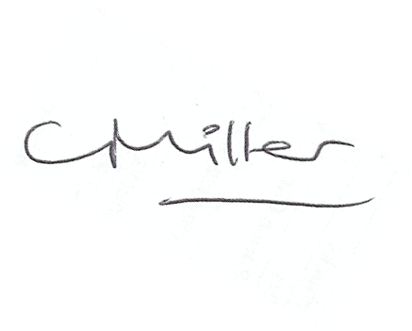
Claire Miller
Parish Clerk

