WALLINGTON DEMESNE PARISH COUNCIL
AGENDA PAPER

You are hereby summoned to attend an ordinary meeting of Wallington Demesne Parish Council to be held at Cambo Village Hall on Monday 25th November 2019 commencing at 730pm, for the purpose of transacting the business contained within this Agenda

2019/80 Apologies for absence
2019/81 Declarations of Members interests
2019/82 Opportunity for members of the public to raise any matter on the agenda
2019/83 Minutes of the meeting held on Monday 23rd September 2019
2019/84 Matters arising from previous meeting held on Monday 23rd September 2019
- Fibre optic broadband
- Cambo seat
- Defibrillator signage at Wallington
2019/85 NCC Update
2019/86 Police Update
2019/87 Reports from representatives at outside meetings
- Cambo School
- Cambo Village Hall
- Middleton Hall
- Wallington F.C.

2019/88 Financial Matters
2019/88/01 Payments for authorisation:
- C Miller – October, November salary & expenses – £418.21
- HMRC – PAYE on above - £2.00
2019/88/02 Request for grant had been received from:
- Community Action Northumberland; Citizens Advice Northumberland
2019/88/03 To approve precept requirements 2020-2021
2019/89 Planning
2019/89/01 Planning Applications received
2019/89/02 Approval of Planning Application received

2019/90 Neighbourhood Management – to report/update on action regarding issues within the parish

2019/91 Correspondence: CPRE newsletter

2019/92 Cambo Burial Ground – to receive update on issues raised at previous meeting

2019/93 Urgent Business

2019/94 Date of Next Meeting
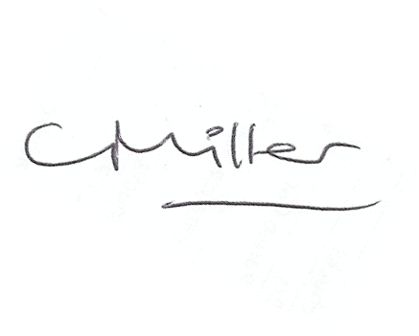
Claire Miller
Parish Clerk

