WALLINGTON DEMESNE PARISH COUNCIL
AGENDA PAPER

You are hereby summoned to attend an ordinary meeting of Wallington Demesne Parish Council to be held at Middleton Village Hall on Monday 23rd March 2020 commencing at 730pm, for the purpose of transacting the business contained within this Agenda

2020/16 Apologies for absence
2020/17 Declarations of Members interests
2020/18 Opportunity for members of the public to raise any matter on the agenda
2020/19 Minutes of the meeting held on Monday 27th January 2020
2020/20 Matters arising from previous meeting held on Monday 27th January 2020
- Fibre optic broadband
- Cambo seat
- Defibrillator signage at Wallington
- Noticeboard
2020/21 NCC Update
2020/22 Police Update
2020/23 Reports from representatives at outside meetings
- Cambo School
- Cambo Village Hall
- Middleton Hall
- Wallington F.C.

2020/24 Financial Matters
2020/24/01 Payments for authorisation:
- C Miller – February, March salary & expenses – £419.20
- HMRC – PAYE on above - £2.
2020/25 Planning
2020/25/01 Planning Applications received
2020/25/02 Approval of Planning Application received

2020/26 Neighbourhood Management – to report/update on action regarding issues within the parish
- Footpaths
- Old National Trust Headquarters building

2020/27 Correspondence
- CPRE newsletter
2020/28 Cambo Cemetery – Review of Burial Fees
2020/29 Review of Internal Auditor/internal controls; Asset Register; Risk Assessment and Insurance Policy

2020/30 Northumberland Association of Local Councils – Member Council Survey Anti-Social Behaviour and Petty Crime

2020/31 Urgent Business
2020/32 Date of Next Meeting
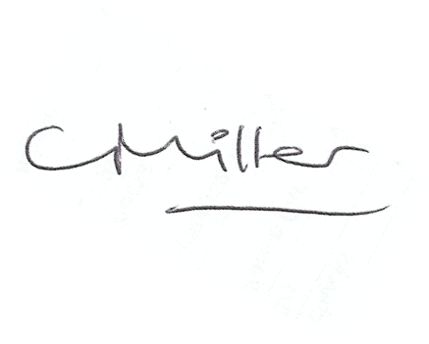
Claire Miller
Parish Clerk

13th March 2020

