WALLINGTON DEMESNE PARISH COUNCIL
AGENDA PAPER

You are summonsed to attend an ordinary meeting of the Parish Council to be held at 730pm on Monday 26th July 2021 at Cambo Village Hall, for the purpose of transacting the business contained within this Agenda. The public are welcome to observe.

2021/53 Apologies for absence

2021/54 Declarations of Members interests

2021/55 Co-Option Vacancies

2021/56 Opportunity for members of the public to raise any matter

2021/57 Minutes of the previous meeting held on Monday 24th May 2021

2021/58 Matters arising from the previous meeting held on Monday 24th May 2021
- Cambo seat
- Footpaths
- Signposts
- Speeding traffic
- Byways Open to all Traffic
- Drainage at Middleton

2021/59 NCC Update

2021/60 Police Update

2021/61 National Trust Update

2021/62 Reports from representatives at outside meetings
- Cambo School
- Cambo Village Hall
- Middleton Hall
- Wallington F.C – extension of lease

2021/63 Financial Matters
2021/63/01 The following payments are due for authorisation
- National Trust – rent for football field
- C Miller – May, June salary & expenses – £422.23
- HMRC – PAYE - £20.40
- Middleton & Todridge Village Hall – meeting room 24/5/21 - £20.00

2021/64 Planning
2021/64/01 Planning Applications received
2021/64/02 Approval of Planning Application received
2021/64/03 Northumberland Local Plan Examination – Consultation on Main Modifications

2021/65 Neighbourhood Management – to report/update on action regarding issues within the paris
2021/65/01 Notice of Application for Modification Order, Right of Way, Greenside Farm
2021/65/02 To consider concerns regarding footpaths
2021/65/03 Northumberland Rivers Trust – River Wansbeck Catchment
2021/65/04 Safety concerns at Payne’s Bridge, Wallington
2021/65/05 To consider Local Transport Plan requirements 2022-2023

2021/66 To receive information regarding B4RN/B4NTR Broadband matters

2021/67 Date of Next Meeting
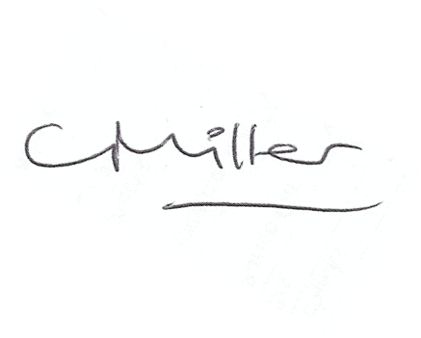
Claire Miller
Parish Clerk

15th July 2021

