WALLINGTON DEMESNE PARISH COUNCIL
AGENDA PAPER

You are summonsed to attend the Annual meeting of the Parish Council to be held at 730pm on Monday 24th May 2021 at Middleton Village Hall, for the purpose of transacting the business contained within this Agenda. The public are welcome to observe.

This will be the first face to face meeting since the Covid-19 pandemic, please see Risk Assessment attached.
2021/35 Apologies for absence

2021/36 Declarations of Members interests

2021/37 Election of Chairman and Vice Chairman

2021/38 Co-Option Vacancies

2021/39 Opportunity for members of the public to raise any matter

2021/40 Minutes of the previous meeting held on Monday 22nd March 2021

2021/41 Matters arising from the previous meeting held on Monday 22nd March 2021
- Cambo seat
- Footpaths
- Signposts
- Speeding traffic
- Byways Open to all Traffic
- Drainage at Middleton

2021/42 NCC Update

2021/43 Police Update

2021/44 National Trust Update

2021/45 Reports from representatives at outside meetings
- Cambo School
- Cambo Village Hall
- Middleton Hall
- Wallington F.C – extension of lease

2021/46 Financial Matters
2021/46/01 The following payments are due for authorisation
- C Miller –April, May, salary - £371.53 Expenses - £24.94
- HMRC – PAYE on above - £20.20
- NALC – annual subscription - £98.23
- Came & Company – annual insurance premium - £357.80

2021/46/02 To receive acknowledgement of grant
- Citizens Advice Northumberland

2021/47 Planning
2021/47/01 Planning Applications received
- 21/00861/FUL: Workshop, Todridge Farm – Conversion of former storage and workshop building into single dwelling
2021/47/02 Approval of Planning Application received
- 20/002345/LBC & 20/02344/FUL: Two Queens, Front Row, Cambo – Listed Building Consent, change of use of redundant detached stable into self contained residential accommodation ancillary to the enjoyment of main house; removal of a non-original fireplace and flue and works of repair, alteration and refurbishment

2021/47/03 Notice of withdrawal of Planning Application
- 21/00721/FUL: Land East of Greenside Grange, Hartburn – Change of use of land to wood reclamation business and construction of secure storage shed to accommodate office and vehicle/machinery storage for business

2021/48 Neighbourhood Management – to report/update on action regarding issues within the parish
2021/48/01 Notice of Application for Modification Order, Right of Way, Greenside Farm

2021/49 To receive information regarding B4RN/B4NTR Broadband matters

2021/50 Audit of Accounts year ending 31/3/21
2021/50/01 To consider and agree any actions arising from the report of the internal auditor
2021/50/02 To approve the Governance Statement
2021/50/03 To approve the draft annual accounts for 2020/2021
2021/50/04 To approve the Accounting Statement and explanation of variances
2021/50/05 To approve the Exemption Certificate
2021/50/06 To approve public right of inspection dates

2021/51 County Council – findings from Library Consultation
https://northumberland.moderngov.co.uk/documents/s2141/Public%20Library%20Service%20Consultation.pdf
https://northumberland.moderngov.co.uk/documents/s2143/App%202.pdf

2021/52 Date of Next Meeting
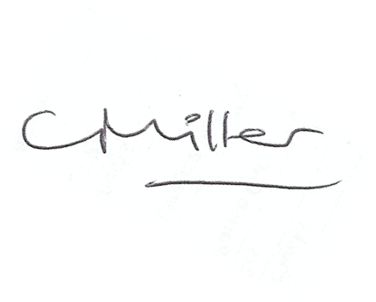
Claire Miller
Parish Clerk

14th May 2021

WALLINGTON DEMESNE PARISH COUNCIL
RISK ASSESSMENT FOR RESUMING FACE-TO-FACE MEETINGS

Risk | Description of Risk | Mitigation Measures
1.Room Set up and Dismantling | Transmission from setting out the chairs to hold the meeting. | Chairs and surfaces, eg door handles to be sanitised after use – members to sanitise their own chairs; Clerk/Chairman to undertake sanitisation on other areas.
2. Entering and leaving meeting | Close proximity to other members and the public entering and leaving the meeting and contact with doors. | Members to enter the meeting and leave in an orderly socially distanced way.  Hands to be sanitised on arrival.  Controlled, socially distanced, one by one, entry by other attendees.
3. Meeting Environment | Transmission through air and touch. | Socially distanced seating arrangement.  Windows and doors to be left open to facilitate the free flow of air though the meeting room.
5. Conduct of Meeting | Transfer through touch and air | Members and public to remain socially distanced at all times.  Wearing of masks except when speaking.  Shouting to be avoided.  The circulation of paper documents to be suspended.
6. Wider Issues | Members do not feel safe attending face to face meetings. | Members to stand when addressing the meeting so their voices will carry better.  Need to keep meeting “moving” so it does not last longer than necessary.
 | Track & trace | Contact details of any members of the public attending to be taken.

Risk Assessment for Face to Face meetings
May 2021
.

