WALLINGTON DEMESNE PARISH COUNCIL

AGENDA PAPER

You are summonsed to attend an ordinary meeting of the Parish Council to be held at 730pm on Monday 27th September 2021 at Middleton Village Hall, for the purpose of transacting the business contained within this Agenda. The public are welcome to attend.

2021/68 Apologies for absence

2021/69 Declarations of Members interests

2021/70 Co-Option Vacancies

2021/71 Opportunity for members of the public to raise any matter

2021/72 Minutes of the previous meeting held on Monday 26th July 2021

2021/73 Matters arising from the previous meeting held on Monday 26th July 2021
2021/73/01 Cambo seat
2021/73/02 Footpaths
2021/73/03 Signposts
2021/73/04 Speeding traffic
2021/73/05 Drainage at Middleton

2021/74 NCC Update

2021/75 Police Update

2021/76 National Trust Update

2021/77 Reports from representatives at outside meetings
- Cambo School
- Cambo Village Hall
- Middleton Hall
- Wallington F.C – extension of lease

2021/78 Financial Matters
2021/78/01 The following payments are due for authorisation
- C Miller – July, August salary & expenses – £414.75
- HMRC – PAYE - £20.40
- Plexus Medial – Spanglefish – annual web-site hosting fee - £103.00

2021/79 Planning
2021/79/01 Planning Applications received
- 21/03028/VARYCO: The Joinery, Wallington Courtyard – Variation of condition 3 to 19/04672/LBC for replacement of rainwater goods
- 21/03029/VARYCO: West House, Cambo – Variation of condition 2 on 20/03754/LBCV in order to put in a new opening on the side elevation of the lean-to extension
- 21/03183/LBC: Wallington Hall – Listed Building Consent for repairs to fountain within walled garden conservatory (including provision of replica lion’s mask spout) and retention of ‘Antonius’ bust and column within Wallington Hall (previously sited within conservatory)

2021/79/02 Approval of Planning Application received
- 21/00861/FUL: Workshop, Todridge Farm, Middleton – Conversion of former storage and workshop building into single dwelling

2021/80 Neighbourhood Management – to report/update on action regarding issues within the parish
2021/80/01 Notice of Application for Modification Order, Right of Way, Greenside Farm
2021/80/02 Northumberland Rivers Trust – River Wansbeck Catchment
2021/80/03 Safety concerns at Payne’s Bridge, Wallington
2021/80/04 To consider Local Transport Plan requirements 2022-2023; Current requests being footpath repairs between Doctors and Oakford, Scots Gap; Footpath repairs to Cambo school and footpath repairs between Oak House and Elm House, Scots Gap.

2021/81 To receive information regarding B4RN/B4NTR Broadband matters

2021/82 To consider invitation for County Council Cabinet Member to meet with Parish Council

2021/83 Date of Next Meeting
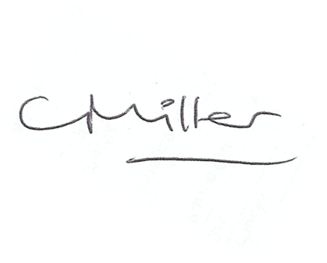
Claire Miller
Parish Clerk

16th September 2021

