Minutes of Wallington Demesne Parish Council meeting held at Middleton Village Hall on Monday 25th January 2016 commencing 730pm
Those Present: J Ballantine (Vice Chairman) D Cowan, A Douglass, S Pattison, K Fortune, S Richards,
S Jones, C Miller (Clerk)

New Cllr Sean Jones welcomed to the meeting.

2016/01 Apologies for absence
E Green, J Aynsley, G Sanderson

2016/02 Minutes of the meeting held 23rd November 2015
The minutes of the previous meeting were agreed as a true record.

2016/03 DECLARATION OF MEMBERS INTERESTS
Members are invited to disclose any Disclosable Pecuniary Interests or other personal interests they may have in any of the items of business on the agenda in accordance with the Code of Conduct.

2016/04 Matters arising from previous meeting
- Clerk had received quotation from NCC supplier, Glasdon, for provision of litter bin at £130.42 plus VAT, with NCC stipulating they would empty fortnightly, however two weeks’ worth of rubbish would have to be evident. It was agreed Clerk would arrange purchase.
- J Ballantine had spoken to ISOS regarding bus shelter, however site meeting pointless as no funding available for improvements.
- Pains Bridge work to be left until Spring.
- Clerk had contacted ISOS regarding site meeting, and representative had spoken to D Ballantine, however with no funding available, site meeting pointless.
2016/05 Reports from representatives at outside meetings
- Cambo First School: Heating system troublesome with school closed for two days; pigs to be delivered in near future.
- Cambo Village Hall: Northumbrian Night held, which had been moderately successful. New roof had made a massive difference to temperature of hall.
- Middleton Village Hall: Cambo Young Farmers, Hartburn Community Project, Canadian Musician and champion Scottish Fiddler all making use of the hall.
- Wallington Football Club: Nothing to report.

2016/06 NCC Update
Glen Sanderson had given apologies.

2016/07 Police Update
Trailers and horse boxes being stolen to order on a regular basis; building sites in Morpeth vicinity being broken into.
2016/08 Financial matters: Balance as at 31/12/15 - £20137.81
2016/08/01 The following invoices were authorised:
- Cambo Village Hall – November meeting hall rental - £12.00
- C Miller – six monthly salary & expenses - £1120.94
- PAYE on above - £7.00
- J Ballantine – J Ballantine declared an interest on payment - £45.00

2016/08/02 Funding request Middleton Village Hall
G Courtice present and gave information regarding possible £450 underspend on village hall project which PC had agreed to fund. Long-term, approximately 80-100K required, with initial commitment of 5% requested from the PC, and it was agreed this would be supported, Clerk to confirm in writing.

2016/08/02 Precept 2016/2017
D Cowan proposed precept to retain at present level of £3500, S Pattison seconded, agreed.

2016/08/03 Funding request Wallington Football Club
Five year plan submitted from Wallington FC, with shower improvements imperative. Clerk to confirm levels PC permitted to donate.

2016/09 Planning applications had been received for the following
- 15/04257/FELTPO: Mrs D Dexter, 8 Willow Park – TPO, sycamore, ash, willow tree – however date for comment being today
2016/09/01 Approval of planning application had been received for the following:
- 15/03848/LBC: Haven House, Cambo – listed building consent, alteration to roof structure and ceiling
- 15/03743/FUL: Mrs J Gibson, The Corridge, Middleton – proposed change of use of land from agricultural and construction of tennis court
- 15/03724/LBC: Mrs J Gibson, The Corridge, Middleton – porch
Refusal of planning application had been received for the following:
- 15/03847/LBC: Have House, alterations and repairs to listed building
2016/10 Correspondence
- Northumberland County Council – winter services
- G Sanderson – Superfast broadband – asking for representatives to sit on committee to further, Clerk to pass S Jones details on to group
2016/11 Neighbourhood Management
- National Trust had employed 12 local person’s from February to October 2016.
- National Trust seeking advice regarding future planning applications.
- A Douglass requested Clerk contact Northern Electric regarding electricity cuts on Tuesday 5th January, with electricity being off from 12 – 6, and 11 hours Saturday 16th January. With Middleton being a vulnerable community, there should be procedures in place to deal with this, however there was concern current problem similar to that of several years ago where improvements to circuitry had had to be made.
- Pothole at 30pmh zone between Grangemoor and Scots, Clerk to contact NCC.
- Streetlamp off at Oakford, Number 6WB, Clerk to contact NCC.
2016/12 Urgent Business
There was no urgent business.
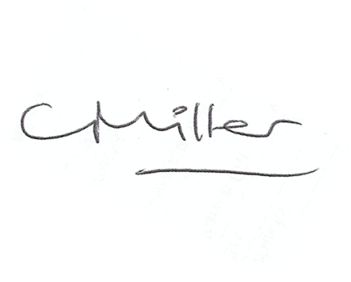
Claire Miller
Parish Clerk

The meeting closed at 830pm.

