Minutes of meeting of Wallington Demesne Parish Council held at Cambo Village Hall on Monday 27th March 2017 commencing 730pm

Those Present: J Ballantine (Chairman), D Cowan, S Pattison, C Miller (Clerk), G Sanderson (County Council),
A Teasdale (Northumbria Police),

2017/15 Apologies for absence
S Richards, E Green, S Jones

2017/16 Minutes of the meeting held on 23rd January 2017
The minutes of the previous meeting were agreed as a true record.

2017/17 Declaration of Interests
J Ballantine declared an interest in payment regarding cemetery works.

2017/19 Matters arising from previous meeting
J Ballantine had met with Chairman of Rothley and Hollinhill PC who have funding to supply defibrillator’s at Cambo and Scots Gap, and a further parishioner could also have access to funding. Cambo Hall committee had agreed to installation of cabinet outside of hall, with National Trust permission. It was agreed to invite Chairman of Hollinghill to next PC meeting, Clerk to arrange.

2017/20 Public questions
There were no public questions.

2017/21 NCC Update
County Cllr pleased to help with Middleton defibrillator; County Council budget recently discussed, with advice to not cut funding on rural roads which appears to be the case; footpaths had been cleaned; County Council to withdraw from speed partnership at Fairmoor; question tabled regarding Morpeth school places; tree felling at County Hall to be raised, as felling licence required which was not obtained; progress with superfast broadband, with half of PC’s now having the service; Glen to stand again in May elections and thanked all for their work over his tenure, and hoped to therefore be present at next PC meeting.

2017/22 Police Update
Trailer/horse box thefts prevalent; power tools/grasscutting equipment stolen at Wallington; diesel thefts prevalent; poaching; information puppies for sale being stolen within Northumberland.

2017/23 Reports from representatives at outside meetings
Cambo Village Hall: Several events to be held in the near future; snooker room thermal ceiling curtain fitted; comment had been made regarding hardstanding works and Village Hall would of liked to be informed of the work.
Cambo School: Pigs insitu, however males in error; fencing; golf tournament; Easter activities at Kirkwhelpington; medieval project at castle.
Wallington FC: Race night held, with scarce attendance but £845 raised; 8th in league; 140th year, with exhibition match to be held.

2017/24 Financial Matters
2017/24/01 The following invoices were authorised for payment:
- Cambo Village Hall – rent for 25/1/17 - £12.00 – not for the Parish Council
- C Miller – February & March salary & expenses - £366.15
- HMRC – PAYE on above - £69.20
- J Ballantine – cemetery gate works- £333.70
- Middleton Village Hall – rent of meeting room - £20.00

2017/24/02 Review of Burial Charges
Current burial charges had been circulated to all and comparisons given to similar sized burial grounds. The following rates were agreed - Burial charge £400 standard charge, parish resident £250.00; cremated ashes £300 standard charge, parish resident £200.00; standard charge for cremated ashes of child upto 12 years of age £150; parish resident £75.00; non resident single gravespace £150 , resident £100; non-resident double grave £250, parish resident £200; right to erect a memorial, non parish £200, parish resident £150.00; subsequent inscriptions £60.00 for non resident and parish resident.

2017/25 Planning Applications
2017/25/01 Planning Applications received
- 16/04733/LBC & 17/0013/LBC: Wallington Hall – supported

2017/25/02 Approval of Planning Application received
- 16/04733/LBC: The Joinery Wallington Courtyard, Listed building consent for removal of existing stone surround and hearth to fireplace.

2017/26 Neighbourhood Management
No issues.

2017/27 May 2017 Elections
Forms to be completed outside of meeting.

2017/28 Correspondence
- Wallington F.C. – exhibition match – Parish Council had given their support in the exhibition match to be held between players past and present on 27th May 2017.
- Northumberland County Council – Residents Festival – 1st and 2nd April 2017

2017/29 Urgent Business
There was no urgent business.

The meeting closed at 825pm.
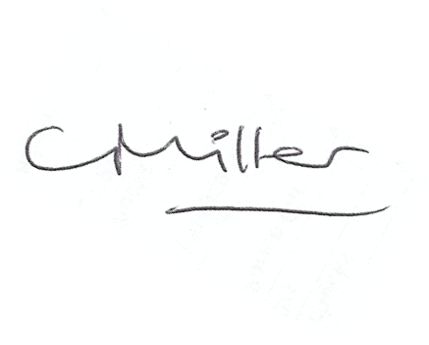
Claire Miller
Parish Clerk

www.parish-council.com/wallingtondemesne/

