Minutes of the Annual meeting of Wallington Demesne Parish Council held at Middleton Village Hall on Thursday 11th May 2017 commencing 730pm

Those Present: J Ballantine, D Cowan, S Pattison, S Jones, C Miller (Clerk),
E Bainbridge, L Sharp (Hollinhill Parish Council)

2017/30 Apologies for absence
E Green, G Sanderson (County Cllr), A Teasdale (Northumbria Police)

2017/31 Appointment of Chairperson and Vice Chairperson
S Pattison proposed J Ballantine as Chairman, S Jones, seconded, all agreed. S Pattison proposed D Cowan as Vice Chairman, S Jones proposed, all agreed.

2017/32 Co-Option Vacancies
Three co-option vacancies had occurred.

2017/33 Opportunity for members of the public to raise any matter on the agenda
There were no matters raised.

2017/34 Defibrillators for Cambo and Scots Gap
Louise and Elizabeth present from Hollinhill Parish Council to discuss funding for defibrillators at Forest Burn Gate, Cambo and Scots Gap. Permission had been agreed for a venue at Cambo Hall in front of the seat. Simonside Show to be approached for donation towards possible cabinet at Forest Burn Gate, Joan Gledson had donated funding of £300, and thought the Ray Wind Farm fund may be able to offer assistance, and County Cllr Glen Sanderson was also willing to donate. A site at the garage in Scots Gap had been agreed for a cabinet, further to the GP surgery suggesting it should be placed elsewhere from their building as currently they have defibrillator machinery inside the surgery. Clerk to contact G Sanderson for confirmation of how much he is willing to donate. Local cycling clubs could be approached for donations due to the high volume of cyclists travelling throughout the parishes.

2017/35 Minutes of the meeting held on 27th March 2017
The minutes of the previous meeting were agreed as a true record.

2017/36 Matters arising from the minutes
There were no matters arising from the previous minutes.

2017/37 NCC Update
G Sanderson had given his apologies.

2017/38 Police Update
Andrea Teasdale had left note of the following: several diesel thefts in Morpeth areas coinciding with break-ins to sheds and outhouses, with garden equipment being the main targets. Reports of a suspicious van which was uplifted with stolen items inside including diesel, with driver now on bail. Reports of poaching had decreased but by no means stopped. Police aware of issues with illegal campers at the Scout Camp at weekends which they can look into.

2017/39 Reports from representatives at outside meetings
Cambo Hall: Fete coming up; John Grundy to attend an event; proposal for band to hold an event; cycle event coming up;
Cambo First School: Pigs eventually swapped for females.
Wallington FC: One game left and celebrations for 140th anniversary to be held end of May. Flyers were to be placed indicating parking on the day of event.

2017/40 Financial Matters
2017/40/01 The following invoices were authorised for payment: Cambo Village Hall - £12.00; C Miller, April & May salary/expenses £358.11; HMRC – PAYE, £72.40; NALC – annual subscription - £88.98; Zurich Municipal - £286.78
2017/40/02 Audit of Accounts year ending 31/3/16: to discuss and approve Annual Governance Statement and Accounting Statements year ending 31/3/17 Section 1 Annual Governance Statement: Clerk read out all points which. Year end financial figures circulated to all.

2017/40/03 Review of bank signatories
Clerk proposed bank mandate be amended to allow two signatories for each payment, as opposed to three, and Clerk be added to mandate in order to carry out BACS payments, proposal carried.

2017/41 Planning Applications
2017/41/01 Planning Applications received
17/00001/FUL: Mr S Purvis, West Grange, Scots Gap, 16 loose box and stables and extension of access road.
2017/41/02 Approval of Planning Application received
- 17/00013/LBC: Mr J Griffiths, listed building consent to replace lead down spout with cast iron, Wallington Hall

2017/42 Neighbourhood Management
There were no issues.

2017/43 Annual review of Risk Assessment
Document had been circulated to all and it was agreed clerk would create new table onto excel, S Jones to forward template to Clerk.

2017/44 Correspondence
- NALC – notice of vacancies on County Committee for members of this parish – nobody able to attend at the present time.

2017/45 To discuss issues relating to Cambo Cemetery
A grave had become sunken with funeral director then refusing to attend site stating it was the Parish Council’s responsibility. After much stress to the family involved, they had eventually attended site and rectified the problem.

2017/46 Urgent Business
There was no urgent business.

The next meeting of Wallington Demesne Parish Council will be held on Monday 24th July 2017 commencing 730pm in Cambo Village Hall.

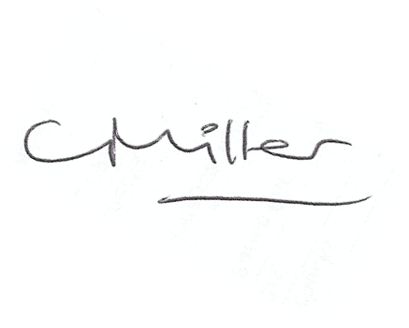
Claire Miller
Parish Clerk

The meeting closed at 850pm.

