Minutes of ordinary meeting of Wallington Demesne Parish Council held at Middleton Village Hall on Monday 27th January 2020 commencing at 730pm

Those Present: J Ballantine (Chairman), D Cowan, V Bland, C Hughes, R Boucher, D Dexter, C Miller (Clerk),
G Sanderson (NCC), A Teasdale (Northumbria Police)

2020/01 Apologies for absence
A Robson, E Green, S Richards

2020/02 Declarations of Members interests
J Ballantine declared an interest in payments.
D Cowan declared an interest in planning application for 25 Oakford, Scots Gap.

2020/03 Opportunity for members of the public to raise any matter on the agenda
There were no members of the public present.

2020/04 Minutes of the meeting held on Monday 25th November 2019
The minutes of the previous meeting held on Monday 25th November 2019 were accepted as a true record.

2020/05 Matters arising from previous meeting held on Monday 25th November 2019
- Fibre optic broadband: Nothing to report.
- Cambo seat: Seat not yet insitu due to contractor illness.
- Defibrillator signage at Wallington: Signage now in place.

2020/06 NCC Update
Local Transport Plan 2020-2021 priorities currently being confirmed. Additional funds for rural roads had been submitted, and an increase in larger farming machinery is causing problems with road maintenance. Additional car parking space at Morpeth train station and further parking sites to be created in Morpeth, Alnwick, Amble and Berwick. 20mph speeding limit at Cambo school should be actioned next financial year.

2020/07 Police Update
Recent spate of thefts of portaloos had occurred, one from Meldon kennels; heating oil thefts reported in Longhorsley; poaching problematic and instances should be reported via telephoning 101.

2020/08 Reports from representatives at outside meetings
- Cambo School: Additional swimming sessions to take place; pigs not available until April, therefore alternative supplier being sought.
- Cambo Village Hall: Christmas events well attended; Easter community meal planned; Hall committee members to attend Ray Wind farm meeting scheduled for March.
- Middleton Hall: Nothing to report.
- Wallington F.C: New dug-outs and poles to be installed. Games are now being held in the ground, further to adverse weather conditions. It was suggested vehicles park in Mart Yard in bad weather, further to car being stuck on soft ground – J Ballantine to suggest this to committee.

2020/09 Financial Matters
2020/09/01 Payments for authorisation:
- Cambo Village Hall – rent for meeting room 25/11/19 - £9.00
- C Miller – December, January salary & expenses – £425.37
- HMRC – PAYE on above - £2.00
- J Ballantine – cemetery hedgecutting - £120.00
It was resolved to authorise payments

2020/10 Planning
2020/10/01 Planning Applications received
- 19/04671/LBC: 3 Graham’s Corner, Wallington, renew roof – no objections
- 19/04672/LBC: The Joinery Wallington, repointing chimney stack and other works – no objections
- 19/04670/LBC: 6 Wallington Courtyard, refurbishment works – no objections
- 19/04603/LBC: Holy Trinity Church, Cambo, maltese cross – no objections
- 19/04984/FUL: 25 Oakford, side and rear extensions – no objections

2020/10/02 Approval of Planning Application received
No approval of planning application had been received.

2020/11 Neighbourhood Management – to report/update on action regarding issues within the parish
- Footpaths: Left hand side footpath from Cambo to Scots Gap had been actioned, however footpath from Blacksmith’s Shop to Cambo school had not been actioned and there was also a drain in this location requiring attention - Clerk to report to County Council.
- Old National Trust Headquarters building: Work currently being carried out inside the building, and it was anticipated work to the parish trust properties would take two years. The long-term use of the building would be decided at Head Office.
- Tidy up at Scots Gap: Scheduled for 8/2/20.
- Noticeboard: The Parish Council noticeboard at Scots Gap is completely rotten - J Ballantine could possibly repair the structure.

2020/12 Correspondence
- CPRE newsletter; Clerks & Councils Direct.

2020/13 Northumberland County Council – Consultation on library services
Northumberland County Council were carrying out a consultation on library services with survey available on-line https://surveymonkey.co.uk/r/NCCLibraryConsultation

2020/14 Urgent Business
Correspondence had been received regarding regulations at Cambo Cemetery as regards memorial headstones, suggesting a separate area be designated for the interment of ashes and a marker stone permitted to be placed over the spot just below the level of the ground so that mowing is not interrupted. After discussion it was resolved at the present time no changes would be made to the Cambo Cemetery regulations.

2020/15 Date of Next Meeting
The next meeting of Wallington Demesne Parish Council will be held on Monday 23rd March 2020 commencing 730pm in Cambo Village Hall
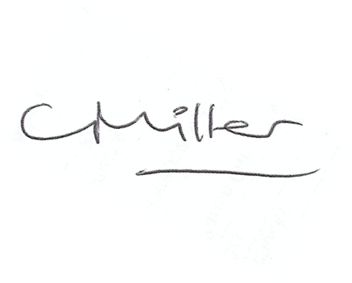
Claire Miller
Parish Clerk

The meeting closed at 8pm.

