**Draft Report on Clerks Salary Grade**

**October 2022**

**Background**

In 2005 the National Association of Local Councils (NALC) and the Society of Local Council Clerks (SLCC) issued a joint agreement on Terms and Conditions including a new approach to job evaluation, placing town and parish council jobs on an equal footing with other local government roles

When appointing a Clerk, the Council is choosing the holder of a responsible public position who will have the qualities to properly discharge the Council’s powers and duties and carry out representative tasks associated with the wider role of the Council.

The Council should act as a responsible employer in the recruitment, employment and management of its staff and make use of good employment practice

The final decision on salary has to be agreed between the council and the officer at appointment, but the National Agreement between NALC and SLCC provides a reasonable salary and terms and conditions standard for clerks. The below information includes the recent NALC pay increase agreed in October 2022.

**Salaries**

NALC and SLCC strongly advise that the starting salary of a Clerk to the Council should, as a minimum, be paid in accordance with the ranges set out below.

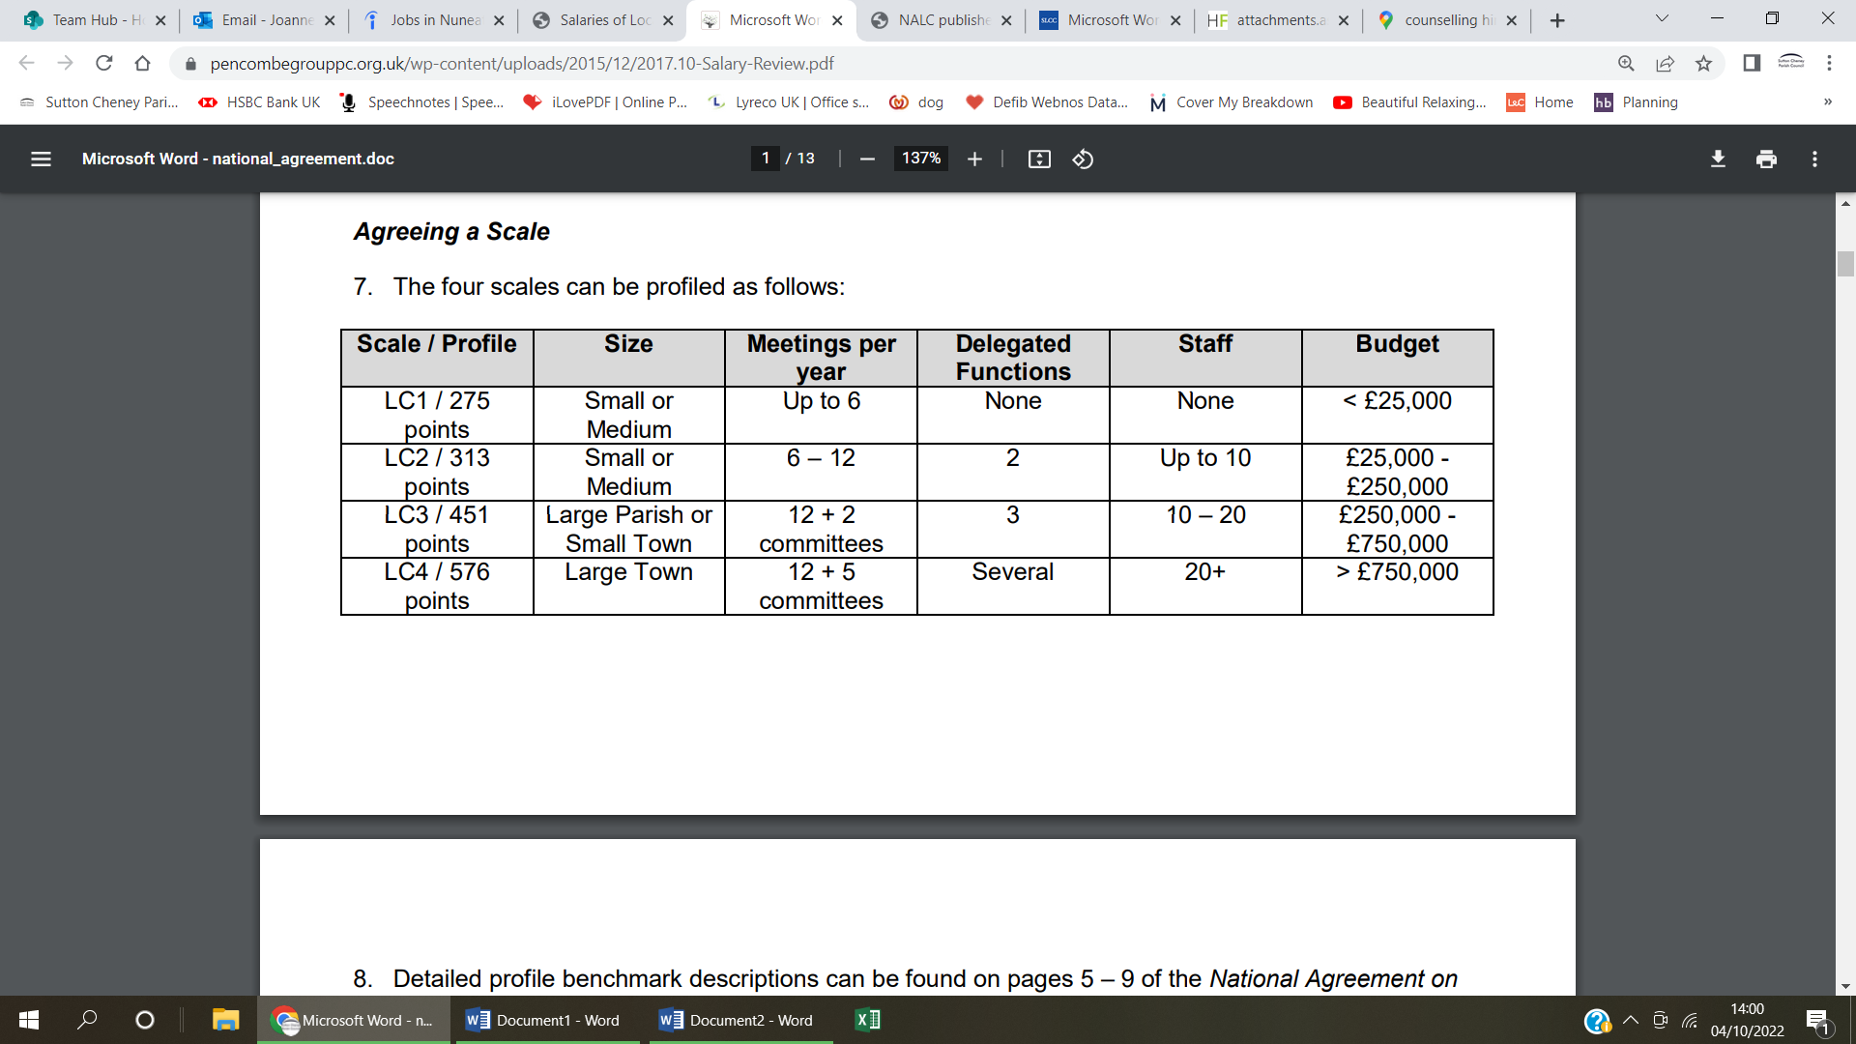

Salary is then calculated by assessing the Clerk’s job description (see appendix 1 for standard template) against 8 profile statements to result in one of 12 possible salary ranges, by slotting it into one of the four profiles (LC1, LC2, LC3 or LC4) and then further defining whether it is ‘substantive’, ‘below substantive’ or ‘above substantive’.

The most suitable scale for Cadeby PC falls within LC1 so the various benchmarks within that range are detailed as below:

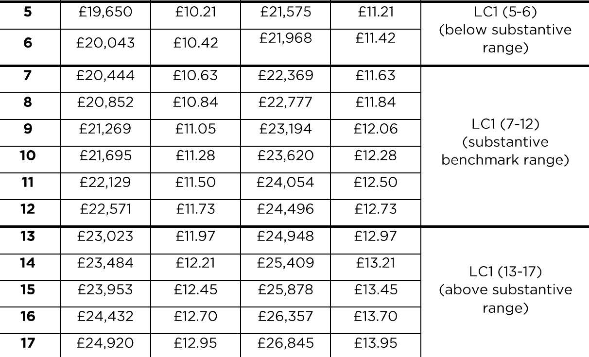

When considering benchmarks, the role of Clerk should be matched to a series of 8 statements about the following aspects of the job. The outcome of this assessment is that the salary benchmarks for the Parish Clerk at Cadeby Parish Council is **LC1 substantive.**

Having established the benchmark salary for the post, the Council to decide EITHER:

a. to adopt a salary scale within the range. The salary will rise annually, by automatic increase on the 1st April each year, by incremental steps, to the scale maximum.

b. to adopt a single salary point (a ‘spot salary’) within the range. Where a single salary point is adopted the Council should review the salary annually.

**Working Time**

The Council will determine the hours to be worked and must ensure that the working week is sufficient to meet the demands of the Council’s work. Part-time officers are remunerated pro rata at an hourly rate derived from the salary for a full-time post. The hourly rate is calculated by dividing the annual full-time salary, including any additions or allowances, by 52 weeks, to produce a weekly figure, and to divide that figure by 37, being the standard number of hours work by a full-time officer. Under employment legislation any part-time member of staff much be offered the same terms and conditions as a full-time worker.

**Annual Allowance**

The clerk should receive an annual sum to take into account the use of space, lighting, heating and electricity due to working from home.

This is usually £100 per annum.

**Recommendations**

The Clerk recommends that Council considers that at the next full Parish Council meeting, that all information within this report to resolve the Clerks salary grade that can be offered during the recruitment process.