

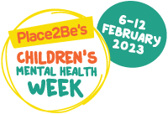

Take part in Children’s Mental Health Week and help make a difference to the lives of children and young people across the Highlands.

Children’s Mental Health Week 2023 will take place from 6-12 February 2023. This year’s theme is “Let’s Connect.”

A wide range of activities and support can be found here: [Childrens mental health week.](https://www.childrensmentalhealthweek.org.uk/)

[**Top tips**](C://Users/jmccre/Downloads/Top_tips_for_parents_and_carers.pdf) **for Parents Carers and those working with or supporting young people.**

Here are a few simple ways you can connect with children and young people and help them to make meaningful connections.

* Connect with the child or young person in everyday ways
* Talk to the child or young person about important connections
* Talk to the child or young person about their friends
* Connect by taking an interest in their world
* Try to resolve conflict and re-connect after arguments

Let the child or young person know that if they are worried about something, they should always talk to an adult they trust. It could be you, someone in your family, a teacher or someone else in their school.

Additional information and resources for Childrens Mental Health Week 2023 can be found using these links:

[Children’s Mental Health Week - Children's Health Scotland (childrenshealthscotland.org)](https://www.childrenshealthscotland.org/chs-proud-to-support-childrens-mental-health-week/)

[www.highlandwellbeing.co.uk](https://nam12.safelinks.protection.outlook.com/?url=http%3A%2F%2Fwww.highlandwellbeing.co.uk%2F&data=05%7C01%7CJames.McCreath%40highland.gov.uk%7C8df4c06db5b74191849208daf3ea0fc0%7C89f0b56e6d164fe89dba176fa940f7c9%7C0%7C0%7C638090483844274188%7CUnknown%7CTWFpbGZsb3d8eyJWIjoiMC4wLjAwMDAiLCJQIjoiV2luMzIiLCJBTiI6Ik1haWwiLCJXVCI6Mn0%3D%7C3000%7C%7C%7C&sdata=Nkx1gRmhbY740sgnkkHE%2FfNGlNP%2BGFhxr%2FmnIb3sR58%3D&reserved=0)

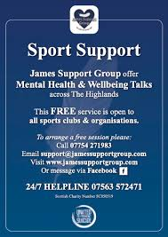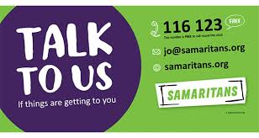

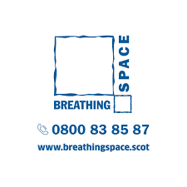

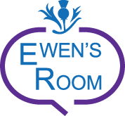

Text us: [07537 431637](http://www.ewensroom.com/helpline)

Call us: [01967 401130](tel:01967401130)



**If you need someone to talk to, please text us via SMS at 07786 20 77 55, through WhatsApp at 01463 729 000, or contact us via messenger, webchat or twitter Sun-Thurs 6pm - 10pm, Fri-Sat 7pm-7am.**

**Or come and visit us at: The Hive, 19 Academy Street, Inverness Sun-Thurs 6pm-10pm & Fri-Sat 6pm-11pm.**

**The Hive, 19 Academy Street, Inverness IV1 1JN**

**For young people**

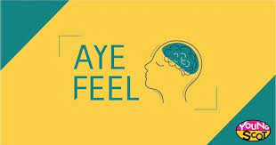

Find information about how to look after your emotional wellbeing and mental health, discover support from organisations around Scotland and tips on how to promote a positive mindset.

Check out the #AyeFeel tag on social media for the latest updates.

For Parents Carers and those working with or supporting young people**.**

**Promoting Children and Young People’s Mental Health and preventing Self-Harm and Suicide Animations**

Three educational animations support learning about mental health, self-harm and suicide prevention specifically for the wider Children and Young People’s workforce. These animations support individuals to understand the factors that influence mental health and resilience in children and young people; engage proactively with children and young people about mental health, self-harm and suicide; and recognise when to seek help to support those in their care.

Target Audiences: These animations are specifically developed for those individuals working with Children and Young People.

Timings: Each animation is around 6-7 minutes. Although these can be utilised on their own, it would be recommended that these are used as part of a wider learning activity.

Access: [https://learn.nes.nhs.scot/33734](https://eur02.safelinks.protection.outlook.com/?url=https%3A%2F%2Flearn.nes.nhs.scot%2F33734&data=05%7C01%7CJames.McCreath%40highland.gov.uk%7Cbcb46775792341ac3ea908dad1f358ab%7C89f0b56e6d164fe89dba176fa940f7c9%7C0%7C0%7C638053140350297354%7CUnknown%7CTWFpbGZsb3d8eyJWIjoiMC4wLjAwMDAiLCJQIjoiV2luMzIiLCJBTiI6Ik1haWwiLCJXVCI6Mn0%3D%7C3000%7C%7C%7C&sdata=ma5UkwMBjQel0FbGSlcQ9rfbM%2FrqJTJimwaCu95G3zQ%3D&reserved=0)

### [**Kooth - Online Counselling Service**](https://www.google.com/url?q=https%3A%2F%2Fwww.kooth.com%2F&sa=D&sntz=1&usg=AOvVaw0ZInq1oX_z5ZyZA0687Iex)

[Kooth](https://www.google.com/url?q=https%3A%2F%2Fwww.kooth.com%2F&sa=D&sntz=1&usg=AOvVaw0ZInq1oX_z5ZyZA0687Iex) have recently been commissioned by NHS Highland as an integral component of Highland’s mental health provision offering a digital counselling and emotional well-being service for young people.

This service will complement the existing Schools Counselling Service and is available 7 days a week, 365 days a year. For more information visit the link provided above.

Please e-mail [Highland.Cares@highland.gov.uk](mailto:Highland.Cares@highland.gov.uk) for further information.

**Connecting with Nature**

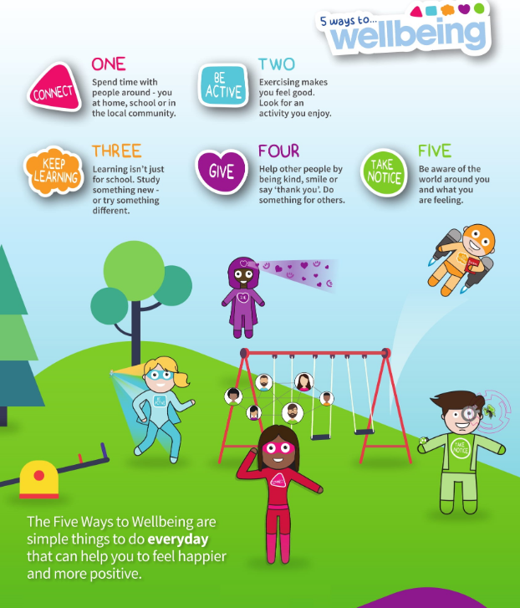

Connecting with Nature and the world around you - taking a walk, spending time outdoors, doing something to help address the threats to our natural world, growing something!



Less than half of adults in Scotland visit the outdoors on a regular, weekly basis, and 14% don't at all.

Access to greenspace can help to protect the physical and mental health of both adults and children in Scotland.

[Highland Green Health Partnership](https://www.thinkhealththinknature.scot/)

