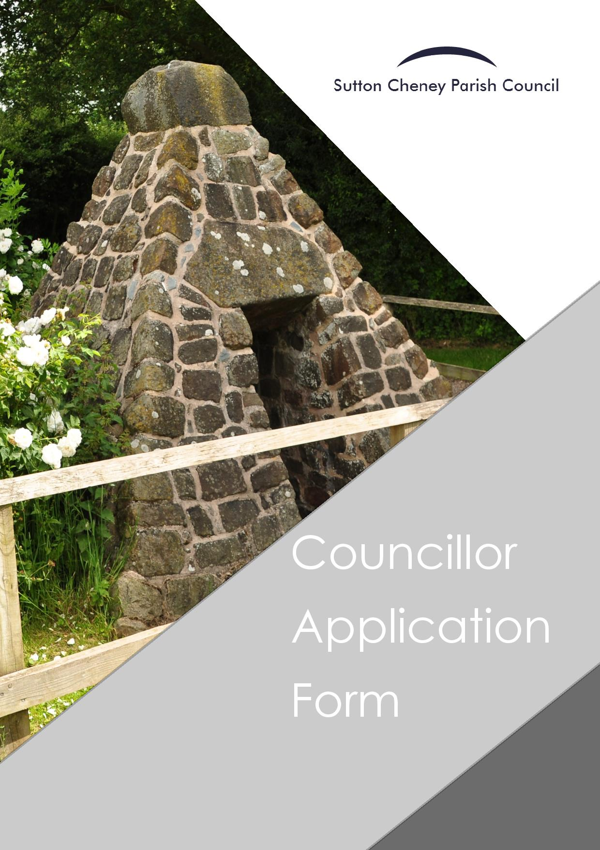

Thank you for your interest in applying for the role of Parish Councillor for Sutton Cheney Parish Council.
We welcome applications from people who have an interest in their local area with a willingness and enthusiasm to represent the views of local people. Candidates must also have the ability to communicate clearly and effectively and be willing to work alongside a variety of people to deliver local projects and events.
The Parish Council works closely with partners such as village hall committees, voluntary groups, Leicestershire Police as well as other the other tiers of local Government, namely Hinckley and Bosworth Borough Council and Leicestershire County Council. Introductory training forms part of the induction process for all new Councillors and ongoing training covering a variety of different topics will be available as an ongoing basis.
No previous knowledge or experience is required to become a Parish Councillor you must fulfil the following criteria to be an eligible candidate:
- 18 years of age of over at the date of application;
- A Commonwealth citizen, a citizen of the Republic of Ireland or a citizen of another Member State of the European Community; and
- A local government elector within the parish; or
- Have worked in the parish for the last 12 months; or
- Have lived in the parish, or within 3 miles of it, for the last 12 months; or
- Owned land/property in the parish area for the last 12 months.

You also not eligible if you hold a paid office or any other position of profit within the Parish Council or have been disqualified from being elected by reason of any set out below:

- Surcharged by the District Auditor for £500 or more
- Disqualified by a court from holding public office
- Declared bankrupt at some point in your life
- Convicted of an offence where the sentence of imprisonment was more than 3 months (even if the sentence was suspended)
- Found guilty of corrupt or illegal practices under Election Laws

.
The Parish Council’s Members’ Code of Conduct relates to the standards required of members of the Council. If your application to be co-opted is successful, you will be required to complete the Members’ Register of Interests and agree to follow this code. Completed forms are held by the Monitoring Officer at Hinckley and Bosworth Borough Council and are published online.

As a Councillor you will be expected to regularly attend scheduled meetings and failure to do so will result in disqualification. The Parish Council meet 10 times each year alongside other committees or extraordinary meetings as scheduled.

If you have any further questions, please contact the Parish Clerk who will be happy to help. We look forward to receiving your application for consideration at the next Parish Council meeting.

APPLICATION FOR CO-OPTION OF SUTTON CHENEY PARISH COUNCIL
Please tell us why you want to become a Parish Councillor. What skills, knowledge and experience might you be able to bring to the role?

Name:

Address:
Telephone Number:
Mobile Number:

Email:

Continued…..

By signing this form, you agree that:

- You have read and understood the information within the Supporting Information for Co-Option document attached to this pack
- If you are elected as a Parish Councillor, you must sign the Declaration of Office form as well as your Register of Interest form within 28 days of being co-opted onto the Council
- You understand that failure to attend Parish Council meetings for a continuous period of 6 months will result in disqualification

If you have any further questions, please contact the Parish Clerk on 01455 699618 or email suttoncheneypc@gmail.com.
Thank you for your interest in becoming a Parish Councillor for Sutton Cheney Parish Council.
Signed: Date:

Please return this form to the Parish Clerk at suttoncheneypc@gmail.com before the advertised deadline for your application to be considered at the next Council meeting

