Grounds Maintenance Services
3 Year Tender – 2023 - 2026

Contract Terms

Sutton Cheney Parish Council require the grounds maintenance contractor to:

- Maintain the grounds as detailed in Grounds Maintenance Scope' throughout the period of the contract and to provide a maintenance schedule (subject to weather conditions).
- Provide all plant, labour and materials to carry out the operations detailed within this contract.
- Provide evidence of insurance with public liability cover to a minimum of £5,000,000. Should a policy be renewed during the contract period, please forward the renewal to the Parish Clerk.
- Provide a copy of their Health and Safety Policy which meets the requirements of the Health and Safety at Work Act.
- Conduct a risk assessment for each task undertaken.
- Provide a minimum of three references on request.
- Clearly state whether VAT is included in the quoted price.
- Provide an invoice on a monthly basis (to be received by the Parish Clerk no later than the last working day of the month). Payment will be made via BACS payment and will be made within 3 working days of the Parish Council meeting taking place. Meeting dates are available on the Council's website - www.parish-council.com/suttoncheney
- Collect and dispose of any litter in the areas to be mown, strimmed or trimmed in a responsible manner.
- Leave the grass cuttings to lie
- Remove hedge trimmings and dispose of in a responsible manner.

The contract period will run for the period of 3 years from March 2023 until October 2026, subject to normal break clauses.

For further information please contact the clerk on 01455 699618 or email suttoncheneypc@gmail.com
Deadline for submissions: XXX

Dadlington Village Green, The Green / Main Street, Dadlington

- To cut the grass and leave the cuttings to lie.
- To strim the areas up to and around trees, fixed obstacles and up to hedgerows.
- Strim around the boundary of Dadlington Village Hall

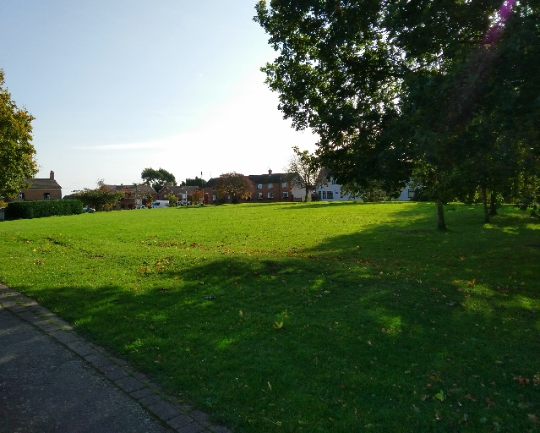
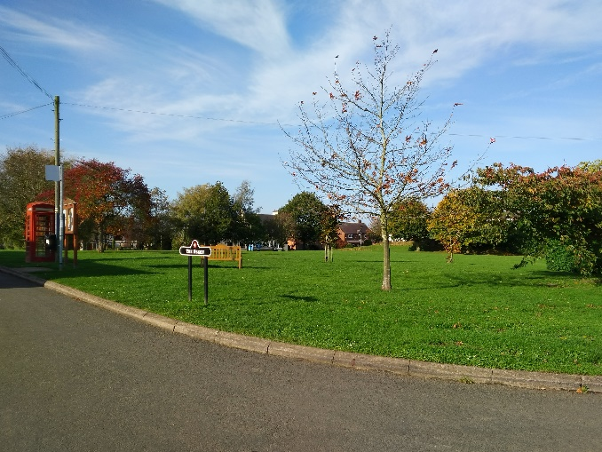

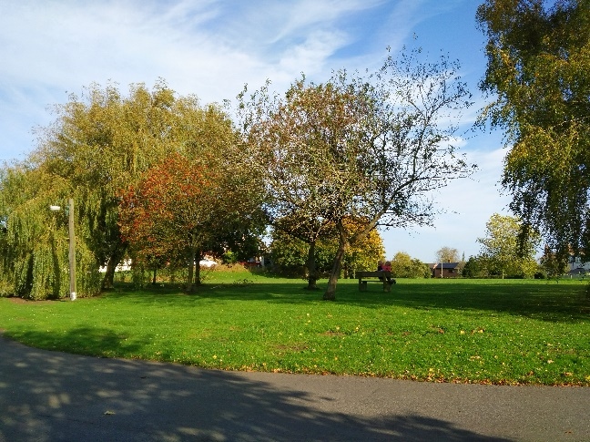
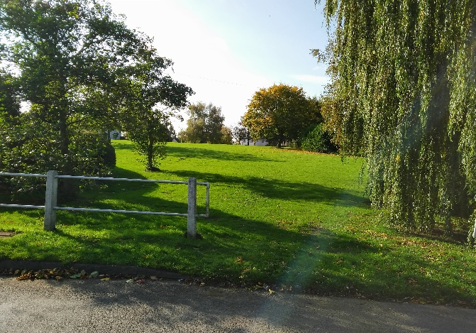

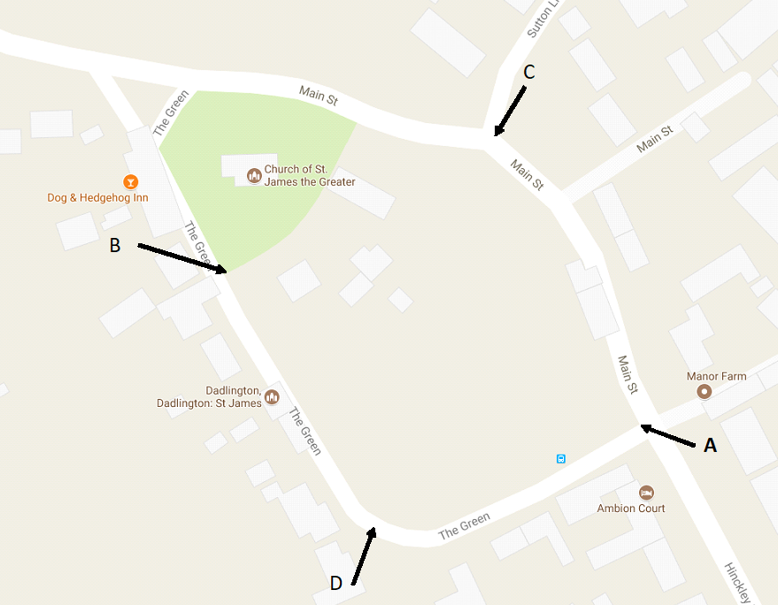

Frequency of Cuts: 14 Cuts per year - 1 Cut in March, bimonthly cuts April – Sept, 1 cut in October

St James Churchyard, The Green / Main Street, Dadlington

- To cut the grass and leave the cuttings to lie.
- To strim the areas up to and around trees, headstones and up to/underneath hedgerows.
- To trim the inside, top and underneath of hedges and trees (as shown in red)
- To trim the outside hedge/trees (as shown in blue)

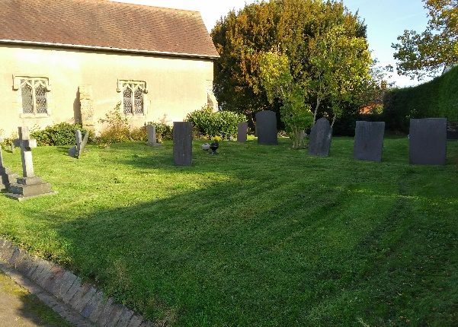
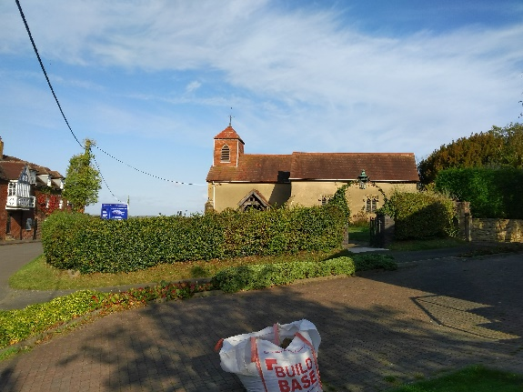

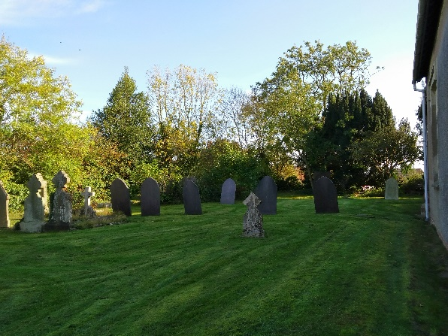
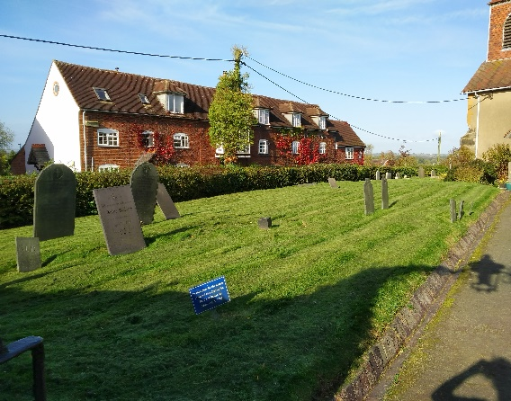

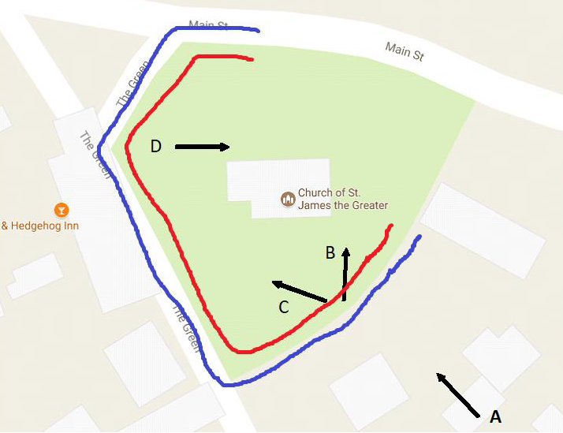Dadlington Green, The Green / Main Street, Dadlington
Frequency of Cuts: 12 Cuts per year – 1 cut in March & April, bimonthly cuts May – August, 1 cut in September & October
Frequency of Strims: 12 strims per year – 1 strim in March & April, bimonthly strims May – August, 1 strim in September & October
Hedge Trims: 2 trims per year – 1 early spring and 1 in early autumn

