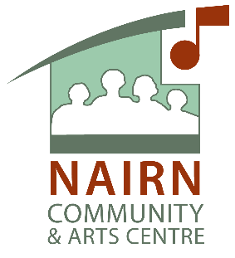
Membership of Nairn Community & Arts Centre

Nairn Community & Arts Centre is a company limited by guarantee. In simple terms this means we have ‘members’ as opposed to ‘shareholders’ and we as a company must be able to clearly identify who the ‘members’ are. As a Board we recognise that not all our users wish to be a member of the Company. Being a member of Nairn Community & Arts Centre entitles you to attend meetings called by the Board, including AGM’s and EGMs, and to vote on matters brought forward by the Board.

Application to become a member of Nairn Community & Arts Centre
I (Full name):

currently residing at (address and postcode)

apply to be a member of the company known as Nairn Community & Arts Centre in accordance with the terms set out in the Memorandum and Articles of Association. I understand that this entitles me to attend general meetings called by the Board and grants authorisation to vote on matters brought forward by the Board. I confirm that I have attained the age of 18. My contact details are:

Email address:

Telephone No:

Signature: Date:

