Meeting of Kenmore and District Community Council
Kenmore Reading Rooms

25 August 2022 7pm

Minutes

Present
Peter Ely, Carol May, Colin Morton, Alex Low, Shirley Shearer, John McGarry, John Duff, Billy Duff
Apologies
Liz Stott, Olive Munroe
Declarations of Interest
None
Previous Minutes
No matters arising
Finance
Rich (Treasurer) was unable to attend. Financial update expected at next meeting.

- Taymouth Castle and Kenmore Hotel Update
1.1 Planning
The development is based on the approved 2005 & 2011 planning applications. Some updates are required to bring work undertaken previously up to the standard required for current building regs, SEPA requirements etc. All changes are being made in conjunction with PKC and Historic Scotland and full listed building consent has been obtained.
Updated planning requests have been submitted for the security office and a plant building (previous approval given for the required plant to stand outside on a concrete base).
As focus moves to the residential properties in the grounds more changes to planning consent will be raised primarily to bring the designs up to current building control standards. All planning applications will be shared on KCC website for visibility and comment.
1.2 KCC Sub-group meetings with DLC
Peter Ely, Colin Morton and Shirley Shearer as representatives of KCC are in regular contact with DLC. The main discussion points have been around the list of local improvements currently underway with the support of DLC. DLC are keen to be supportive of the local community and further requirements can be added to the list for consideration. Interactions with DLC have all been positive and DLC has been working well with the KCC reps.
DLC will also start to work with the other local community councils. A joint meeting of DLC and the 4 local community councils will be arranged through DLC/KCC.
The list of community items to be considered is currently being formalised including details of the party responsible and the target date of completion. The formalised list will be shared when available and will be based on the items currently in hand. Peter Ely updated the current status of these items as below:
- Kenmore Beach – benches, life belt (as per request from First Responders) and notice boards have been added. Toilets have been made available opposite the beach. Work will be undertaken to improve pavements and bollards. Additional parking available next to sports ground. A new entrance to additional parking is planned opposite the beach. Disabled access and removal of sewage pipe also planned.
- Reading Rooms – Notice board to be replaced. Survey undertaken by Stricklands to determine what improvements could be made. Upstairs room available to KCC for meetings and wi-fi has been installed.
- Kenmore houses - Flower baskets added to several local properties. Houses are being lived in by DLC employees.
- Stables – DLC had been in discussions with to current owner. It is understood owner will instead be moving to stables adjacent to Mains of Taymouth Golf Course.
- Kenmore Primary School – DLC has made donation to school and will support the school’s project currently underway in the garden/wooded area.
- Kenmore in Bloom – work in progress
- Rubbish – DLC will arrange to remove on request.
- Repurposing Telephone Box – have reviewed other local uses of the phone boxes for ideas. The Acharn telephone box was used for food/book donations during the pandemic. Prior to covid it had been planned to fill with plants. The box in Kenmore may be used as the starting/end point of a kids trail that is planned. Final plan tbc.
- Kenmore Games – supported by DLC.
- Salmon Fishing – DLC keen to support opening and closing of the salmon fishing season.
- Local signage – commercial signs at corner of beach to be reviewed/removed. Improve directions to Castle.
- Footpaths - work continues on improving foot paths and many of the rhododendrons have been cleared within the castle grounds. All core paths will be retained but may require re-routing in some cases. DLC will consult with KCC on any potential re-routing of foot paths. The Chinese Bridge will also be reinstated. There is NO plan to prevent or fundamentally change access and Scottish access laws will be respected. Preventing access would not be permitted under Scottish Law in any case.
- Loch Tay Code of Conduct – Loch Tay Users Group, Taymouth Marina and DLC to agree potential restrictions and then review with other interested parties.
- Taymouth Trading – Kenmore Bakery has been consulted and will be involved in supporting the proposed café/bakery.
- Kenmore Graveyard – potential solutions to lack of space are under consideration.
The following were raised as potential items that could be included in the list:
- Life belts at Dalerb and Acharn
- Benches on Acharn beach
KCC reps also met with those behind the ‘Save Kenmore’ Facebook page. There still appears to be some scepticism re whether Taymouth Castle/DLC will be true to their word on supporting the local community. KCC’s interactions with DLC have all been very positive and have raised no cause for concern. The overall feeling is one of optimism.
It was agreed that more regular updates should be made on the KCC Facebook page and website to share details of the progress made to date on local concerns.

- Kenmore Shop/PO - Progress Update
Representatives of the Breadalbane Development Trust met with KCC reps (Peter Ely, Shirley Shearer and Colin Morton) and Robert Sharp from the Post Office to review what would be involved in re-opening the post office.
The costs were confirmed as £16k to re-open and provide machinery. A £5k grant would be available to assist with these costs. However, given the historical level of use of the Kenmore post office the viability of re-opening is in doubt. Robert Sharp indicated that in the past Kenmore post office averaged 120 transactions a week. The number of transactions required to make a post office viable in its own right is in the region of 10 times the current level ie. 1200 to 1300 transactions a week.
It would only really be sustainable if the Post Office was run as part of another retail enterprise where the PO encouraged additional foot fall for the primary business. The plan to open the Post Office as a standalone venture in the Reading Rooms would not be commercially viable. DLC would be prepared to support if a potential retail business could be identified who would see the benefit in running the Post Office also.
Peter Ely indicated that the current owner of the shop/PO has now confirmed that the business has been sold to a 3rd party. The details of the purchaser have not disclosed to KCC. It is expected that the shop will re-open under the new owner by the end of 2022. It was agreed that discussions around the PO would resume when the shop re-opens at the end of the year and the new owner is known. It may be that the PO will encourage footfall in the new retail enterprise and would therefore be a benefit to the new owner.
In the mean time it was agreed that if any local residents are struggling to get to the Post Office in Aberfeldy that they should let KCC know. KCC will then review potential solutions in terms of providing transport in the short term. Potential solutions could be accessing funds available under the Upper Tay Transport group to improve bus services. This could include increasing the frequency of bus services on the 91 route. These initiatives could be considered if a need is confirmed.
- Loch Tay
Complaints have been received regarding jet skis launched from Dalerb. Restrictions to be enforced under of the Loch Tay Code of Conduct should help to address these concerns (see section 1.2 above).
- Footpaths
As per the updates under section 1.2 above improvements are underway as part of the Taymouth Castle work through DLC.
- Planning
Updated planning application received for plant room at Taymouth Castle as per update under section 1.1 above.
Planning approval granted for ‘4 The Braes’ to be converted from residential to holiday let. This approval was granted despite objections from KCC on the basis of lack of affordable housing. The approval is subject to review in 2 years when the Short Term Lets legislation due to come into force in Oct will be more widely understood.
- AGM
Local Community Council elections will take place on 3rd November. Details of the timetable are confirmed below:

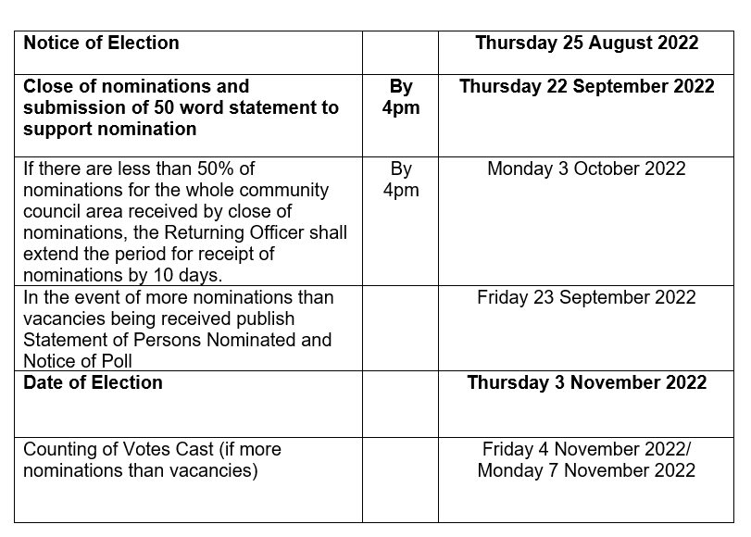
There are 8 positions on the Kenmore and District Community Council – 4 for Kenmore and 4 for Acharn. Carol May confirmed she will be standing at this election. All members of the KCC who wish to remain on the Community Council should complete the nomination form. Carol May advised that Liz Stott indicated she would be happy to stand again.
The date of the AGM is still to be confirmed.

- Date of Next Meeting
Next meeting will be held on Thurs 29th September.

Alex Low
Minute Secretary

