**Links via our website from NHS Inform Scotland:**

[**Coronavirus (COVID-19): General advice**](https://www.nhsinform.scot/illnesses-and-conditions/infections-and-poisoning/coronavirus-covid-19/coronavirus-covid-19-general-advice/)

What coronavirus is, how to avoid catching it and what you must do if you or others in your household have symptoms

[**Coronavirus (COVID-19): Check your symptoms**](https://www.nhsinform.scot/illnesses-and-conditions/infections-and-poisoning/coronavirus-covid-19/coronavirus-covid-19-check-your-symptoms/%20)

Self-help guide to find out what to do next if you or others in your household have coronavirus symptoms

[**Coronavirus (COVID-19): Physical distancing**](https://www.nhsinform.scot/illnesses-and-conditions/infections-and-poisoning/coronavirus-covid-19/coronavirus-covid-19-physical-distancing/)

Why physical distancing is important to stop the spread of coronavirus and who is most affected

[**Coronavirus (COVID-19): Shielding**](https://www.nhsinform.scot/illnesses-and-conditions/infections-and-poisoning/coronavirus-covid-19/coronavirus-covid-19-shielding/)

Why shielding is important to stop the spread of coronavirus and who is most affected

[**Coronavirus (COVID-19): Ask NHS inform a question**](https://www.nhsinform.scot/illnesses-and-conditions/infections-and-poisoning/coronavirus-covid-19/coronavirus-covid-19-ask-nhs-inform-a-question/)

If you have a non-urgent question about coronavirus ask the NHS Inform website for an automated answer

[**GOV.UK: coronavirus – guidance and support**](https://www.gov.uk/coronavirus) Government information and advice.

[**https://www.nhsinform.scot/covid19vaccine**](https://www.nhsinform.scot/covid19vaccine)

Covid-19 vaccine

**Winter newsletter**

**Medical Practice**

**Aberfeldy and Kinloch Rannoch**

We as a practice would like to wish each and every one of our patients a Merry Christmas and a Happy New Year! Fingers crossed 2021 will be a better year for us all with a chink of light at the end of a very long tunnel. Stay safe and please remember:

**F**ace coverings

**A**void crowded places

**C**lean hands regularly

**T**wo metre distance

**S**elf isolate and book a test if you have symptoms

**Covid-19**

We will do our best to keep you up to date with information about Covid-19 and the Covid-19 vaccination, via our Facebook page and website.

We unfortunately do not have news of when the vaccine will be available in our area. Patients will be invited in groups and patients most at risk will be vaccinated first, these are staff and residents in care homes, people aged 80 and over (or will be by the 31st of March 2021), frontline healthcare and social care staff.  Vaccinations for other groups will begin as soon as the supply of vaccine becomes available.  The aim is for every adult in Scotland to be offered the vaccination.  NHS Scotland strongly recommends you have the vaccine as soon as it is offered to you.

**Long term condition reviews**

We would like to encourage our patients to come along for their long term reviews. We are working hard to catch up on these but if you receive a letter from us rest assured that if we ask you to come in for a blood test or an assessment that it is safe to do so. We would like to reassure you that the practice remains open for telephone consultations, video consultations, face to face appointments routine bloods and lots more.

**Aberfeldy**: 01887 820366. **Kinloch Rannoch**: 01882 632216

 So that you can be kept up-to-date with practice information, guidance and support please follow us on our Facebook page <https://www.facebook.com/aberfeldyandkinlochrannochmedicalpractice>



**Flu vaccine.**

Just a wee reminder to say that we still have some flu vaccines left so if you are over 60 years old or in the vulnerable category please just call our reception staff and they will do their best to book you an appointment.

https://www.nhstayside.scot.nhs.uk/YourHealthWellbeing/PROD_311425/index.htm

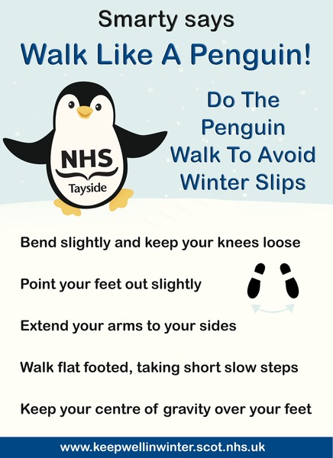

**Breaking news!!!!**

As of the 12th January 2021 both practices will be closed every Tuesday afternoon between 1.30pm and 2.30pm for protected staff education and training.

If you call during this time you will be welcomed by an answer phone message; if you have a medical emergency or are unable to wait until after 2.30pm you will be transferred to a member of the team.

## Vitamin D

We have had a few people calling the surgery regarding the vitamin D tablets that the government are providing. If you are classed as vulnerable and were asked to shield during the pandemic then you should have received a letter informing you that you were now able to receive vitamin D tablets. If, however, you have not received a letter from the government then you can buy vitamin D tablets cheaply from the supermarket or chemist. Please see the link below for more information from the Scottish government.

Vitamin D is important for keeping your bones and muscles healthy. Sunlight is our main source of vitamin D. In Scotland, we only get enough of the right kind of sunlight for our bodies to make vitamin D between April and September. From October to March, we rely on dietary sources of vitamin D. Since vitamin D is found only in a small number of foods, it can be difficult to get enough from food alone.

We recommend that everyone should consider taking a daily supplement of vitamin D. The dose should be 10 microgram (10µg). Especially during autumn and winter when we're unable to make vitamin D from sunlight.

For most people taking a 10-microgram supplement of vitamin D daily is safe. But there are some who should seek advice first due to certain health conditions or medication. This is because taking too much vitamin D can cause calcium to build up in your body and this can weaken your bones and damage your heart and kidneys. You should seek advice from your clinician, specialist nurse, pharmacist, midwife or health visitor if you:

* have known hypercalcaemia (high levels of calcium in the blood - this can be associated with high levels of parathyroid hormone, kidney stones, certain cancers, and chronic kidney disease)
* have sarcoidosis (an inflammatory condition which can affect various parts of the body including the lungs and glands)
* take Digoxin
* take calcium or other vitamin supplements already

https://www.gov.scot/publications/vitamin-d-advice-for-all-age-groups/

https://www.gov.scot/publications/vitamin-d-advice-for-all-age-groups/



**When the weather is icy, we see a sharp increase in the number of people attending the Emergency Departments with slip and trip injuries such as broken bones.**

We would advise people who do need to venture out when the weather is wintery to dress warmly, wear sensible shoes with a good grip and to take care when walking on icy surfaces.  
  
If you want to stay safe whilst walking on icy paths, the advice is to walk like Smarty the penguin – follow our feathered friends and avoid a fall this winter.

[www.keepwellinwinter.scot.nhs.uk](http://www.keepwellinwinter.scot.nhs.uk)



### Online prescriptions.

### Aberfeldy Health Centre

You can order repeat prescriptions in various ways:

* 24 hour answering machine phone line: 01887 829743
* Use our new online services for medication requests

[How to request repeat prescription online](https://www.aberfeldyandrannochsurgery.co.uk/website/S10036/files/Patient%20Services%20-%20Patient%20-%20Requesting%20Prescriptions.pdf)

* Handing in your repeat order form at reception
* E-mail – [tay.aberfeldyprescriptions@nhs.scot](mailto:TAY.aberfeldyprescriptions@nhs.net)
* Telephone – 01887 820366

Please order your prescriptions in plenty of time

**Please allow 4 days for collection from Chemist or 2 working days collected from the surgery**

Urgent Requests – Order by 10am – Collect at surgery by 11.30am the following day.

**NB**: The doctor may wish to see you prior to issuing a repeat prescription. Prescriptions are usually available **within 4 days**of processing and collected at the local chemist unless otherwise instructed.

### Kinloch Rannoch

Kinloch Rannoch is a dispensing practice and urgently needed medicines can be dispensed at the time of consultation.

Repeat prescriptions should be requested by bringing or posting your repeat request slip, phoning or emailing [tay.kinlochrannochprescriptions@nhs.scot](mailto:tay.kinlochrannochprescriptions@nhs.scot). Medication is normally ready for collection after 2 working days (Monday to Friday).





**If you have a muscle, back or joint problem we can now book you a direct telephone appointment with a physiotherapist. Simply call reception and ask to book an appointment**

https://www.nhsinform.scot/-and-conditions/muscle-bone-and-joints

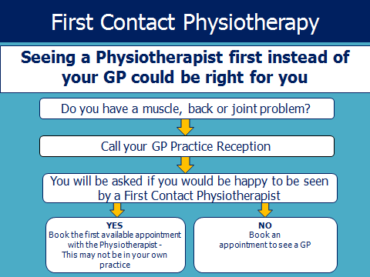

**Exclusion criteria**

Acutely unwell

Children under 16

Medical management of rheumatoid conditions

Women's health, antenatal and postnatal problems

Housebound patients

Medication reviews

Neurological and respiratory conditions

Headaches

Acute mental health crises

Patients who do not wish to see a FCP

Sick note requests

Weight management requirements

Podiatry problems

Walking aid/splints

**Inclusion Criteria**

All soft tissue injuries, sprains, strains or sports injuries

Arthritis – any joint

Possible problems with muscles, ligaments, tendons or bone, e.g. tennis elbow, carpal tunnel syndrome, ankle sprains.

Spinal pain including lower back pain, mid-back and neck pain

Spinal related pain in arms or legs including nerve symptoms, e.g. pins and needles

Changes to walking

Post-orthopaedic surgery

**Video consultations**

Video Consultations are available at Aberfeldy and Kinloch Rannoch Medical Practice.

To access the “Near Me” video consultations you can enter via the Aberfeldy & Kinloch Rannoch Surgery website <https://www.aberfeldyandrannochsurgery.co.uk/> and clicking on the link [**https://nhsattend.vc/aberfeldykinlochrannochmp**](https://nhsattend.vc/aberfeldykinlochrannochmp)

***Please note that you won’t be able to access “Near Me” if you have not gone in through **Google Chrome** or **Apple Safari**\*\*\*

To make an appointment, simply call reception and ask for a video consultation. Once made please log in to the service a little prior to your appointment time to test your connectivity.

All you need to fill in is your full name, date of birth and contact telephone number. You will then enter the surgery's online waiting area. We will be notified when you arrive in the waiting area, and your clinician will join you when ready. There is no need to create an account and no information you enter is stored. If the clinician is running late you will be notified via a message from reception.