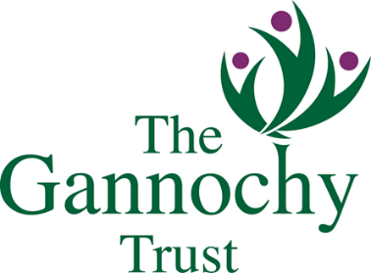

The Funding Roadshow

Discussions are progressing with The National Lottery Community Fund and The Robertson Trust to co-deliver workshops and the programme will vary for each event to reflect the funders in attendance. Further details will be provided as these are confirmed.
The workshops will offer new and existing grant applicants;
• a summary of the funding themes currently available;
• an opportunity for them to put their questions directly to funders;
• an insight into the common issues funders face in assessing applications, and;
• guidance in writing funding applications.

Who should attend?
Trustees, staff or volunteers from smaller third sector agencies are encouraged to attend and, ideally, those who have a strategic role in fundraising for their organisation. Places will be restricted to two per organisation. Please note that access to some funding streams will only be available to registered charities.

Which event should I attend?
There will be 6 workshops repeated across Perth and Kinross with morning, afternoon or evening sessions to choose from. The Roadshows will run from Monday 13 January to Thursday 16 January. Click on your preferred event to book.
Funding Roadshow 2020
Perth • Monday 13 January, 2pm to 4pm (The Gannochy Trust and The National Lottery Community Fund)
Perth • Monday 13 January, 6pm to 8pm (The Gannochy Trust and The National Lottery Community Fund)
Crieff • Tuesday 14 January, 2pm to 4pm (The Gannochy Trust)
Pitlochry • Wednesday 15 January, 2pm to 4pm (The Gannochy Trust and The National Lottery Community Fund)
Kinross • Thursday 16 January, 9.30am to 11.30am (The Gannochy Trust and The National Lottery Community Fund)
Rattray • Thursday 16 January, 2pm to 4pm (The Gannochy Trust)

How much does it cost?
The events are free to attend but booked delegates that do not attend will be charged a non-attendance fee of £50.

