Council reported to Audit Scotland over £45,000 Heart 200 funding handout
by Ross Gardiner
August 30 2019, 9.03am
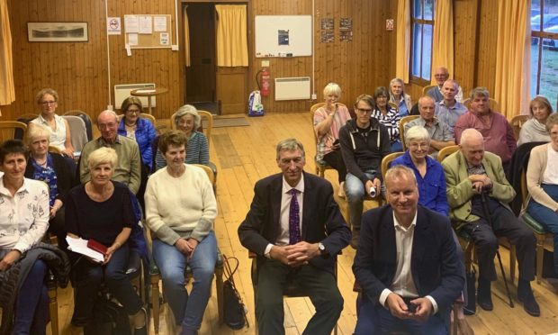
Pete Wishart announced that he has referred the council to Audit Scotland at a public meeting in Tummel Bridge he co-hosted with Cllr Mike Williamson on Wednesday.
Sign up to our Daily newsletter
An investigation has been demanded over how Perth and Kinross Council spend thousands of pounds of public money on a private tourism project.
The local authority was given the grant for the controversial Heart 200 road trip marketing scheme, before any environmental or economic impact analysis was carried out.
Perth and North Perthshire SNP MP Pete Wishart is now in the process of referring the council to Audit Scotland over their handling of the £45,000 given to the organisers of Heart 200.
He made the announcement at a public meeting in Tummel Bridge with Highland ward councillor Mike Williamson on Wednesday, which was organised to hear from the communities who still have concerns about the tourism project.
The organisers of Heart 200 received the grant to help set up the project, as part of the council administration budget in 2018.
The scheme encoruages visitors to drive around a 200 mile loop of Perthshire and Stirlingshire’s top attractions, hoped to rival the North Coast 500 in the Highlands.
But Heart 200 submitted no environmental or economic impact assessment to the council ahead of being awarded the cash.
Mr Wishart is contacting Audit Scotland to ask them to investigate why the five-figure sum was granted by Perth and Kinross Council, following collaborative work with Glenlyon Community Council.
It will be up to auditors to decide if they wish to delve deeper.
Marketing the route has been met with opposition by some local groups who say the infrastructure is not in place to support the additional vehicles and visitors.
Speaking after the public meeting, Mr Wishart said: “The communities in and around the Loch Tummel area raised a number of issues with me at the public meeting on Wednesday and these will be raised directly with Audit Scotland.
“The communities do not feel like Perth and Kinross Council have been taking their concerns very seriously and I feel that the best option is to pass these concerns to an independent body like Audit Scotland.
“Many are concerned about a lack of transparency around the £45,000 of public money and how it was given to one organisation with seemingly no competition or the following of a procurement process.”
The council declined to comment on the referral, but has in the past confirmed the funding was approved when the 2018/19 budget was set.
A council spokesperson previously said: “The funding was allocated as part of the 2018/19 budget, following a motion from elected members, to establish ‘Heart of Scotland’ touring routes around Perth and Kinross that link into existing road, cycle, and rail routes and promote the historical, cultural and environmental attractions across the area.
“Support for Heart 200 was on the basis of a total of £45k over a series of staged payments to assist the development of the initiative.
“This was put through as part of the full council 2018/19 budget meeting, and then passed to the council’s economic development officers to deliver the initiative.”
Audit Scotland have said that they are still to receive confirmation of Mr Wishart’s referral so cannot begin any investigation yet.
Heart 200 management declined to comment.

