Announcing Grow to Give - a new Timebank initiative, March 2021
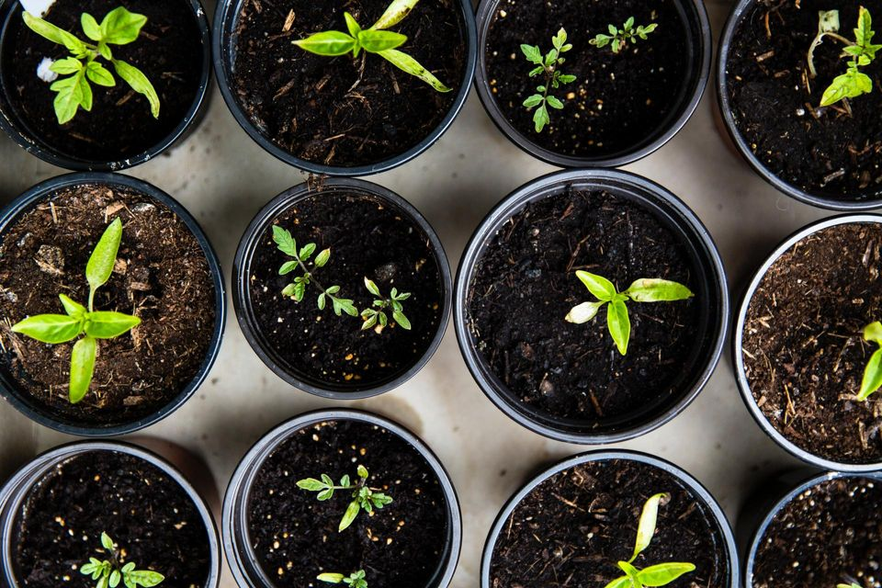
Grow to Give is a new project developed to engage and encourage people across the Tay Valley catchment area to get involved with growing (and sharing) their own food – vegetables, fruit and herbs.

This project has been developed as a local response to national news that an estimated 2m households that will move into food poverty in the UK this year because of the pandemic. It has also been developed as a response to the Scottish Governments vison to increase health and wellbeing in communities through growing and sharing fruit, vegetables and herbs. This project therefore supports Perth & Kinross’s Food Growing Strategy.

By growing food with the aim in mind to share it, as well as growing food together with friends, family and other members of the Timebank or the community, we hope to encourage and enable people to meet and work with others, exchanging time and skills. Through this connectivity and between generations, we will improve social isolation, loneliness, and health and wellbeing in our community.

Ways to get involved:
Request a Pot - it comes with soil and mystery seeds!
Lend and Tend. Offer to share a part of your garden with another grower. We will match you with those that need space.
Post and share images of your efforts onto social media. It will inspire others!
Ask for help. We can help with a range of gardening tasks
Donate. Planning a trip to the Garden Centre, post 5 April? Why not buy a seedling, pot or plant and donate it to us.
We'll arrange for a volunteer to collect, cultivate and share the fruits of their green labour.

Or pop along to the Farmers market stall, 2nd May. Exchange Runner beans for Kale, or pick up sweet peas, and let your leeks loose..

This project will provide advice, inspiration, encouragement, and assistance to participants to grow food on windowsills, patios, in private gardens and, community spaces, as well as with the Biodynamic garden. It will also seek to offer new areas in which participants can grow food.

It will also facilitate the sharing and exchanging of produce between members, and to the public through a community stall at the monthly farmers market in Aberfeldy and potentially local community larders.

We also hold the ambition to devise and deliver a celebration event in August 2021.

We also aim to work with Duke of Edinburgh Award participants and local primary and secondary schools to support and facilitate an intergenerational approach. We recently joined the Generations Working Together charity, to foster and frame our ambitions.

This project will play a role in improving biodiversity, mitigating climate change and reducing food poverty by improving access to high quality local produce that can be grown and distributed in an accessible sustainable manner. In additional, this project will help to increase food growing knowledge and skills and lead to healthier lifestyles.

Want to Grow to Give? Excellent email Giles at tayvalleytimebank@gmail.com

