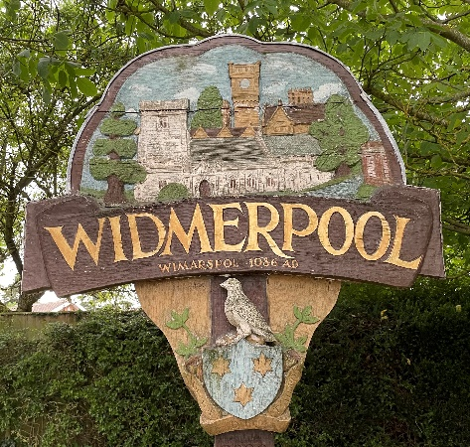
Widmerpool Parish Council

Parish Council Meeting

6th September 2023
Council Members are hereby summoned, and members of the public and press
are invited to attend the next meeting to be held to be held in the Keyworth Rugby Club HQ, Widmerpool on Monday 11th September 2023, 7.00pm.

Emma Goodman
Emma Goodman
Clerk and RFO to the Council
AGENDA
- Apologies

- Declarations of Interest

- Minutes – to approve the minutes of the Parish Council Meeting of 10th July 2023

- Open session for the public (limited to 15 minutes)

- County / Borough Councillor Updates and Questions

- Review and Agree Policies:

- Standing Orders
- Financial Regulations
- Code of Conduct

- Community Speed watch – to further discuss the installation of an Electronic speed sign.

- Village signs – to discuss the quote received and agree the purchase of new village signs.

- Finance
  - Schedule of Payments/Reimbursements
  - Budget report
  - Grant request – 3W’s magazine

- Planning Applications:

- Reference Number: 22/01989/FUL
Granted

- Reference Number: 23/01202/VAR
Granted

- Reference Number: 23/00969/FUL
Granted

- Reference Number 23/01167/VAR
Granted

- Update to flooding and sewerage issues.

- a) Report from Clerk
- Update to Rural housing
- Rushcliffe South Villages Community Safety Group meeting date 17th January 2024 11am
- D Day 80th Anniversary Beacon lighting

b) Reports from Councillors

- Date of Next Parish Council Meeting – Monday 13th November 2023 at 7.00pm

Notes for the Public: Unless otherwise stated all meetings of the Parish Council are open for the public to join. In the interests of transparency, the council asks that any person who wishes to record the meeting proceedings inform the Chairman prior to the meeting. The agenda is structured into four sections – notification of new issues, decisions on priorities and improvements, ongoing management of the council and planning ahead. There is an Open Session on the Agenda at which time members of the public are invited to raise any matters pertaining to the work of the council/agenda items, limited to fifteen minutes, during which the Standing Orders will be suspended.

