INSERT NAME | Community Council
Dates covered by this report: | 26/01/2025 – 06/04/2026
Location: | Rhu and Shandon
Reporting Officer: | PC Craig Cormack


Number of calls to police | 84

Local Policing Priority | Local Good News | How can you help?
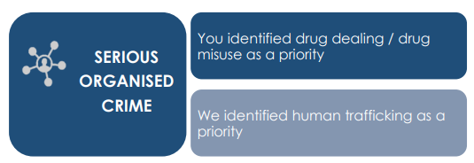 | There have been no reports nor CR’S raised for serious and organised crime. | Your local police would like for your Community Council to help us with tackling Drug related crime by reporting any suspicions you may have either in person or anonymously via 101 or via crime stoppers online:  Crimestoppers in Scotland | Crimestoppers (crimestoppers-uk.org) 0800 555 111
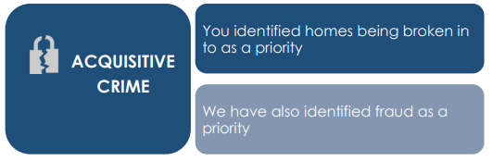 | There have been one CR raised for fraud.  There have been no CR’s raised for theft.  There has been one CR raised for vandalisim. | Your local police would like for your Community Council to help us by following us on our social media channels and help us spread crime prevention advice and guidance.

Local Policing Priority | Local Good News | How can you help?
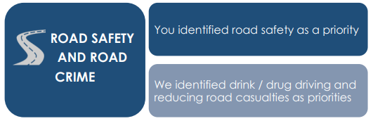 | There have been 6 CR’s raised relating to road safety and road crime in the Rhu area. | Your local police would like for your Community Council to help us with ensuring Road Safety by  by reporting anyone who is suspected of drink or drug driving within your community either in person via 101 or via crime stoppers online:  Crimestoppers in Scotland | Crimestoppers (crimestoppers-uk.org) 0800 555 111
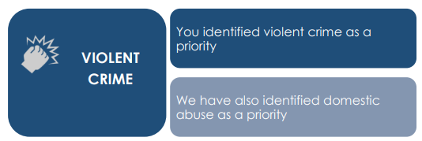 | No CR’s raised. | Your local police would like for your Community Council to help us with tackling Violent Crime by reporting any ASB or community concerns either in person via 101 or via crime stoppers online:  Crimestoppers in Scotland | Crimestoppers (crimestoppers-uk.org) 0800 555 111
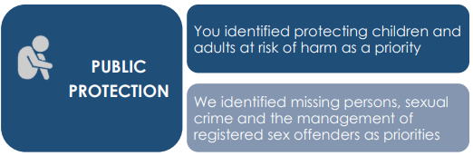 | Three CR’s relating to communication offences. | Your local police would like for your Community Council to help us with helping Public Protection by reporting any concerns you may have regarding potential victims of Domestic Abuse or vulnerable persons, who may be being exploited or who may just need additional crime prevention support to us either in person or anonymous

Useful Links/Contacts

- Argyll and Bute Communtiy Directory - https://abcd.scot/ including warm spaces information
- Crimestoppers – Crimestoppers in Scotland | Crimestoppers (crimestoppers-uk.org) 0800 555 111
- Scottish Partnership Against Rural Crime – www.scottishparc.co.uk
- Women’s Aid - Home - Women's Aid (womensaid.org.uk)
- Citizens Advice – 0808 164 6000
- Argyll and Bute Council Trading Standards – 01546 605 519
- Argyll and Bute Council – https://www.argyll-bute.gov.uk/my-council/how-contact-us
- Transport Scotland – road related incidents and road closures - https://www.traffic.gov.scot/traffic-information/incidents
- Scottish Water - https://www.scottishwater.co.uk/Help-and-Resources/Contact-Us 0800 0778 778
- NHS24 (including mental health support) – 111 or https://www.nhsinform.scot/

Follow us on Social Media and help share loacl appeals and education messages
- Facebook - Police Scotland Argyll and West Dunbartonshire
- X (formerly Twitter) – PSOSArgyllBute and PSOS ArgWestDunb

Sign up to Neighbourhood Watch to receive local alerts and bulletins for your community area - https://neighbourhoodwatchscotland.co.uk/#0

Have your say on your local policing priorities - https://consult.scotland.police.uk/strategy-insight-and-innovation/your-police-2023-2024/

Please Contact the officer below with any feedback or concerns raised at the meeting for further considerations or police action.

Report Completed by | PC Craig Cormack
Contact | 2029528@scotland.police.uk

